by Barbara Minto, printed Tuesday, February 1, 2022
Table of contents
Part 1 Logic in Writing 4
Chapter 1 Why a pyramid structure? 4
Sorting into pyramids 4
The need to state the logic 4
Order from the top down 4
Thinking from the bottom up 5
Chapter 2 The substructures within the pyramid 6
The vertical relationship 6
The horizontal relationship 7
The introductory flow 7
Chapter 3 How to build a pyramid structure 8
The top-down approach 8
The bottom-up approach 9
Caveats for beginners 10
Chapter 4 Fine points of introductions 10
Initial introductions 10
Why a story? 11
How long should it be? 11
Where do you start the situation? 11
What’s a complication? 12
Why that order? 12
What about the key line? 12
In summary 13
Some common patterns 13
Directives 13
Requests for funds 13
‘How to’ Documents 14
Letters of Proposal 14
Progress Reviews 14
Transitions between groups 15
Reference backward 15
Summarizing 15
Concluding 15
Chapter 5 Deduction and induction: the difference 16
Deductive Reasoning 16
How it works 16
When to use it 17
Inductive reasoning 18
How it works 18
How it differs 18
Chapter 6 How to highlight the structure 19
Headings 19
Underlined points 20
Decimal numbering 20
Indented display 21
Part 2 Logic in Thinking 21
Chapter 7 Questioning the order of a grouping 22
Time order 22
Incomplete thinking 22
Confused logic 23
False grouping 23
Structural order 24
Creating a structure 24
Describing a structure 24
Imposing a structure 24
Ranking order 25
Creating proper class groupings 25
Identifying improper class groupings 25
Checking order is a key 29
Chapter 8 Question the problem-solving process 29
The problem-solving process 29
What is the problem? 29
Where does the problem lie? 29
Why does the problem exist? 30
What could we do about it? 30
What should we do about it? 30
Defining the problem 30
Structuring the analysis of the problem 31
Five Typical logic trees 31
Use of the logic-tree concept 32
Chapter 9 Questioning the summary statement 33
Stating the effect of actions 33
Make the wording specific 34
Distinguish the levels of action 36
Drawing an inference from conclusions 38
Find the structural similarity 38
Visualize the relationships 38
Chapter 10 Putting it into readable words 41
Create the image 42
Copy the image in words 42
Summary 42
Appendix Problem solving in structureless situations 42
Analytical abduction 43
Scientific Abduction 43
Techniques of Problem Solving 44

Part 1 Logic in Writing
If a person’s writing is unclear, it is most likely because the ordering of the ideas conflicts with the capability of the reader’s mind to process them. The writer who forces himself to match the structure of his writing to that of his reader’s mind also finds that he has clarified his thinking sufficiently to write less awkward sentences. The first section of the book explains why the structure in a reader’s mind always be a pyramid and the logical substructures that make up that pyramid. It tells you how to use this knowledge to identify the ideas you need to include in a particular document and to structure a clear relationship between them. Finally, it tells you how to highlight your structure so that the ideas and their relationships will be easy to see immediately.

Chapter 1 Why a pyramid structure?
Some fundamental findings of the way the mind works:
- The mind automatically sorts information into distinctive pyramid groupings to comprehend it.
- Any grouping of ideas is easier to comprehend if it arrives presorted into its pyramid.
- This suggests that every written document should be deliberately structured to form a pyramid of ideas.

Sorting into pyramids
The mind automatically imposes order on everything around it has long been recognized. It tends to see any sequence of things that occur together as belonging together and therefore sets about imposing a logical pattern on them. You assume the ideas that appear together, one after the other, belong together and attempt to impose a logical pattern on them. The pattern will always be that of a pyramid because this is the only format that meets your minds need–
- Stop at the magical number seven.
- State the logic of the relationship.
There is a limit to the number of ideas you can comprehend at any one time. The mind can not hold more than about seven items in its short-term memory at any one time. Some minds can hold as many as nine items, while others can hold only five. A convenient number is three; the easiest number is one. When the mind sees the number of items with which it is being presented begin to rise above four or five, it starts to group them into logical categories so that they can be retained.

The need to state the logic
All mental processes (e.g., thinking, remembering, problem-solving) utilize this grouping and summarizing process so that the information in a person’s mind might be thought of as being organized into one giant conglomeration of related pyramids. If you think about communicating to that mind, you can see that the problem is ensuring that what you say will go somewhere into the existing pyramids.
Now we come to the real problem of communicating. You can ‘see’ these groupings of items quite clearly. Communicating with them means ensuring that the other person ‘sees’ them the same way. The most efficient way to do this would be to present the category first and then the items. To order the ideas from the top down.

Order from the top down
Controlling the sequence in which you present your ideas is essential to clear writing. The most apparent sequence is always to give the summarizing idea before you give the individual ideas being summarized. In a manner outside anyone’s control, the reader will look for a structure connecting the ideas as they come to him. To make sure he finds the one you intended, you must tell him in advance what it is – to make sure he knows what to look for. Otherwise, he is likely to see an unintended relationship, or worse, none, in which case you have both wasted your time.
You must recognize that a reader has only a limited amount of mental energy available to him, no matter how intelligent. Some of it will be used up just recognizing and interpreting the words, a further amount seeing the relationships between the ideas, and whatever is left comprehending their significance. You can economize his need to spend time on the first two activities by presenting the ideas to be comprehended with the least possible mental effort. To sequence them instead so that the mind has to go backward and forward to make connections is terrible manners, and most readers react by refusing to do so.
A reader remembers from the top-down as a matter of course. All of this suggests that the clearest written documents will be those that consistently present their information from the top down in a pyramid structure.

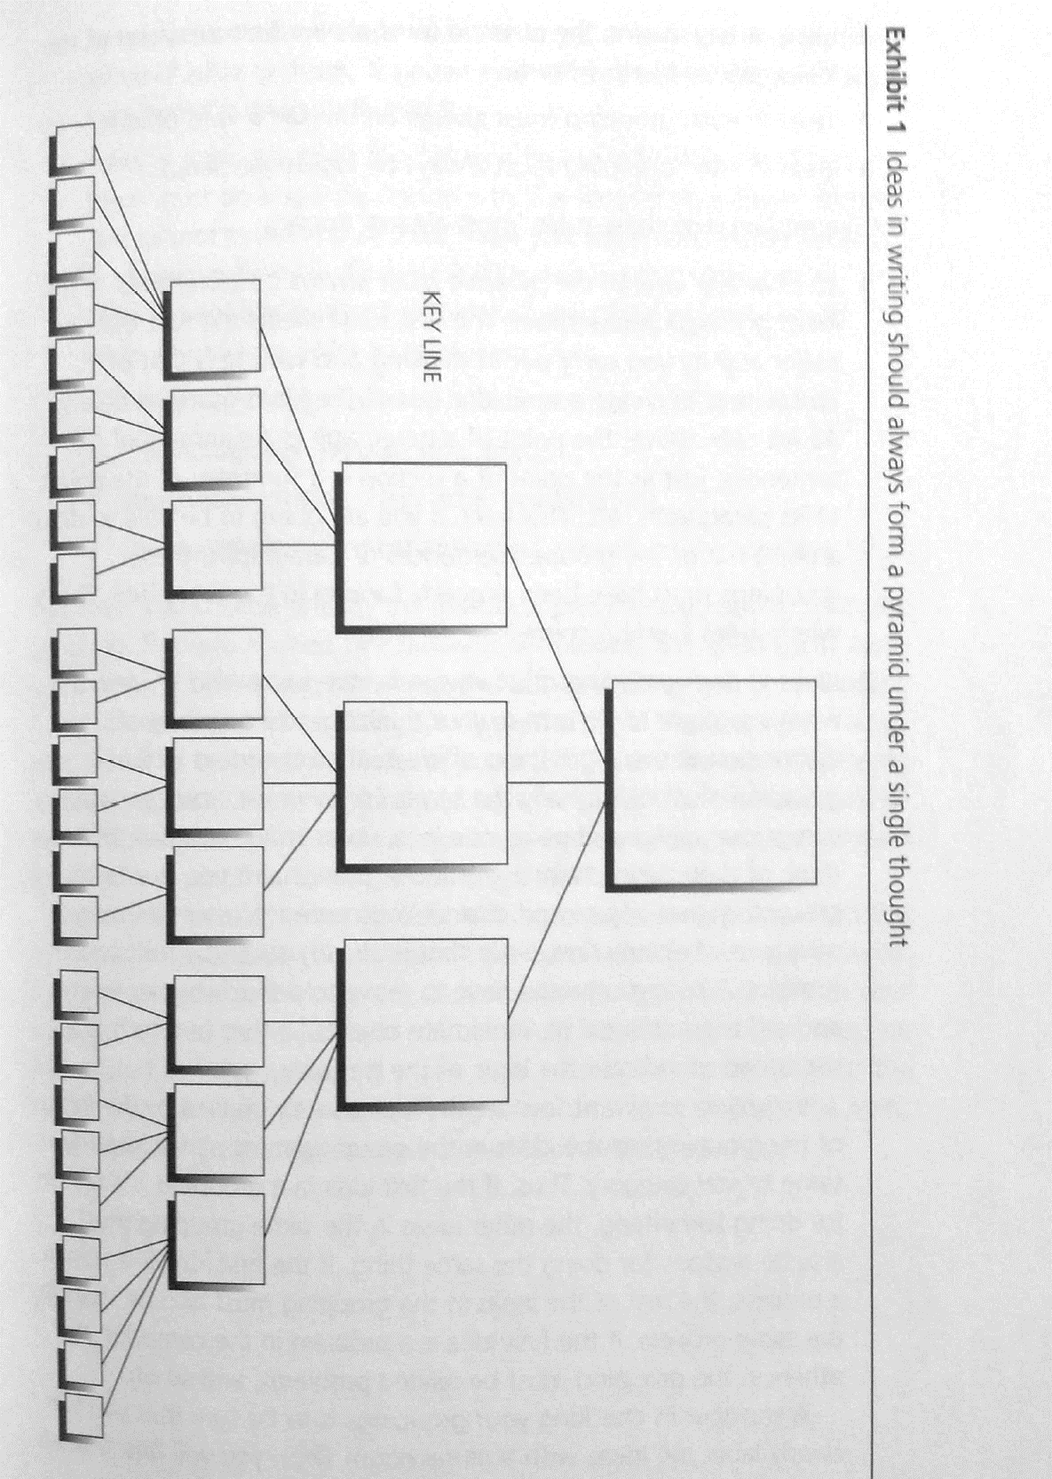
Thinking from the bottom up
If you think for a moment about what you do when you write, you can see that you develop your major ideas by thinking in this bottom-up manner. At the very lowest level in the pyramid, you group your sentences into paragraphs, each containing an individual idea.

You will continue grouping and summarizing until you have no more relationships to make; every document you write will always be structured to support only one single thought – the one that summarizes your final set of groupings. This should be the major point you want to make, and all the ideas grouped underneath – provided you have built the structure properly – will explain or defend that point in ever greater detail. You can define in advance whether you have built the structure properly by checking to see whether your ideas are related to each other in a way that would permit them to form pyramidal groups. You must obey three rules:
- Ideas at any level in the pyramid must always be summarized of the ideas grouped below.
- Ideas in each grouping must always be the same kind of idea.
- Ideas in each grouping must always be logically ordered.
In writing, you want to state the idea directly implied by the logic of the grouping, so the ideas in the grouping must all fall into the same logic category. If the first idea in a grouping is a reason for doing something, the other ideas in the same grouping must also be reasons for doing the same thing. If the first idea is a step in a process, the rest of the ideas in the grouping must also be steps in the same process. If the first idea is a problem in the company, the others in the grouping must be related problems, and so on. A shortcut in checking your groupings is to be sure that you can clearly label the ideas with a plural noun. You will find that all the ideas in the grouping will be things like recommendations, reasons, problems, or changes. The ideas in each grouping must be of the same kind, described by one plural noun.
There must be a specific reason why the second idea comes second and cannot come first or third. There are only four possible logical ways in which to order a set of ideas:
- Deductively – major premise, minor premise, conclusion
- Chronologically – first, second, third.
- Structurally – Boston, New York, Washington.
- Comparatively – first most important, second most important, etc.
The order you choose reflects the analytical process you used to form the grouping. If it was formed by reasoning deductively, the ideas go in argument order; if by working out cause-and-effect relationships, in time order; if by commenting on an existing structure, the order dictated by the structure; and if by categorizing, order of importance. Since these four activities – reasoning deductively, working out cause-and-effect relationships, dividing a whole into its parts, and categorizing – are the only analytical activities the mind can perform, these are the only orders it can impose.
The key to clear writing is to slot your ideas into this pyramid form and test them against the rules before you begin to write. If any of the rules are broken, it is an indication that there is a flaw in your thinking, that ideas have not been fully developed, or that they are not related in a way that will make their message instantly clear to the reader. You can then refine them until they obey the rules, thus eliminating the need for vast amounts of rewriting later on.

Chapter 2 The substructures within the pyramid
You can not hope to sit down and start arranging your ideas into a pyramid; you must discover them first. But the pyramid dictates a rigid set of substructures that can speed the discovery process. There are:
- The vertical relationship between points and subpoints.
- The horizontal relationship within a group of subpoints.
- The narrative flow of the introduction.

The vertical relationship
Any idea below the main point will always have a vertical and a horizontal relationship to the other ideas in the document. The vertical relationship serves marvelously to help capture the reader’s attention. It permits you to set up a question/answer dialogue that will pull him with great interest through your reasoning. Why can we be so sure the reader will be interested? Because he will be forced to respond logically to your ideas.
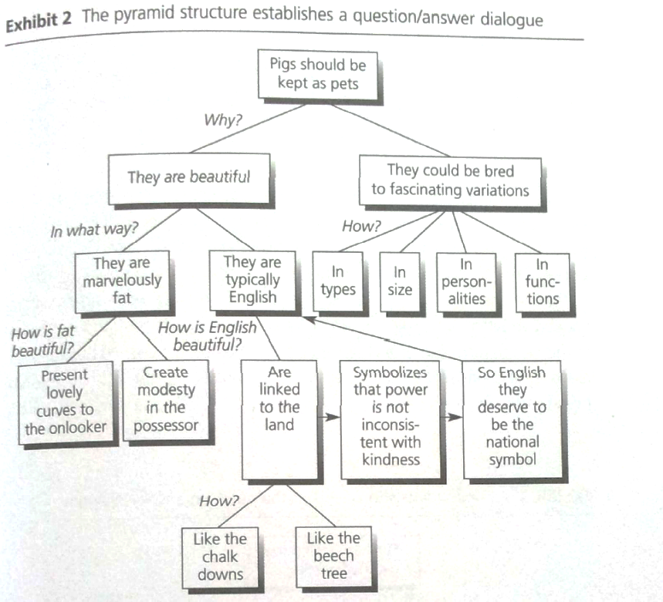
I define an idea as a statement that raises a question in the reader’s mind because you tell him something he does not know. The writer will continue to write, raising and answering questions until he reaches a point at which he judges the reader will have no more logical questions. The reader will not necessarily agree with the writer’s reasoning when he’s reached this point, but he will have followed it clearly, which is the best any writer can hope for. The writer is now free to leave the first leg of the pyramid and return to the Key Line to answer the original question raised by the point in the top box. The Key Line is the points under the major idea directly.
The way to ensure total reader attention is to refrain from raising any questions in the reader’s mind before you are ready to answer them. Or from answering questions before you have raised them. Consequently, the information will have to be repeated at the relevant point in the dialogue.
The pyramid structure forces you to present information only as the reader needs it – the question/answer technique works to hold the reader’s attention without burdening you with the need to think about the relevance of the content.

All documents should reflect the question/answer dialogue. A great value of the pyramid structure is that it forces visual recognition of this vertical relationship on you as you work out your thinking. Any point you make must raise a question in the reader’s mind, which you must answer horizontally on the line below.

The horizontal relationship
In deciding what to say on the line below, not only must the points you include answer the question raised by the point above, but they must also answer it logically. That is, they must present a clear inductive or deductive argument, one or the other, but not at once. These are the only two types of logical relationships possible in a grouping. In writing, if your answer is deductive, you know you must argue which the second point comments on the subject or predicate of the first, and the third point draws a ‘therefore’ from the previous two. If it is inductive, you know the ideas in grouping must be logically alike and designated by a plural noun.
Given this knowledge, you can see that anyone idea in the pyramid implies all the others. Consequently, you could start to build your pyramid anywhere, with a single idea, adding the other ideas as they were demanded – either up or down or sideways. But there is one more thing you need to know before you venture off to build a pyramid of your own – the question to which your document must answer. You determine that by tracing the narrative flow of the introduction.

The introductory flow
This question/answer dialogue cannot be counted on to engage his interest unless the statement that starts it off is relevant to him. The only way you can be confident of its relevance is to make sure that it directly answers a question you have identified as already existing in his mind. You write primarily to tell people what they don’t know. But a reader wants to find out what he doesn’t know, only if he needs to do so. He will have no question if he has no need, and vice versa. Make sure your document is of interest by directing it toward answering a question that already exists in the reader’s mind or that would exist if he thought for a minute about what is going on around him. The introduction identifies that question by tracing the history of its origin.
Since history will be a narrative of events, it should follow the classic narrative development pattern. It should begin by establishing the time and place of a situation for the reader. In that Situation something will have occurred, known as the Complication, that caused him to raise the Question to which your document will give him the Answer. This classic pattern of story-telling – Situation, Complication, Question, Answer – permits you to make sure that you and the reader are ‘standing in the same place’ before you take him by the hand and lead him through your thinking. It also gives you a clear focus for the point at the top of your document and thus a means of judging that you are conveying the right message most directly. An example –
A normal introduction
The purpose of this memorandum is to pull together some ideas for further reflection and discussion in such questions as:
- Composition of the Board and its optimum size.
- A conception of the Board roles of the Board and the Executive Committee, the specific responsibilities of each, and the relationships of one to the other.
- Making the outside Board member an effective participant.
- Some principles dealing with the selection of Board members and their tenue.
- Alternate ways for the company to get from where it is to where it wants to be in Board and Executive Committee operations.
A revised one, force it into the narrative mold
The new organization installed in October places full authority and responsibility for running the day-to-day activities of the two divisions squarely on the shoulders of the managers of those divisions. This move frees the Board to deal entirely with the broad matters of policy and planning exclusive responsibility.
However, the Board has oriented itself to dealing with short-term operating problems for so long that it cannot focus its attention on long-range strategy development. Consequently, it must consider the changes needed to permit itself to do so. Specifically, we believe it should:
- Relinquish responsibility for day-to-day operating matters to the Executive Committee
- Broaden its composition to include outside members
- Establish policies and procedures to formalize the internal operation.

In summary, the introduction tells the reader, in story form, what he already knows or could reasonably be expected to know about the subject you are discussing, and thus reminds him of the question he must which he can predict the document to give him an answer. The story sets forth the Situation within which a Complication developed that raised the Question to which your document will now give the Answer. Once you state the Answer - the main point at the top of your pyramid, it will raise a new question in the reader’s mind that you will answer on the line below.
What does the existence of these three substructures – the vertical question/answer dialogue, the horizontal deductive or inductive logic, and the narrative introductory structure – do for you in helping you discover the ideas you need to build a pyramid? Knowing the vertical relationship, you can determine the ideas you need in each grouping (i.e., those answering the question). Knowing the horizontal relationship, you can judge that the ideas you bring together are like-kind (i.e., proper parts of an inductive or deductive argument). And most important, knowing the reader’s question will ensure that all the ideas you bring together are relevant (i.e., exist only because they help answer that question).

Chapter 3 How to build a pyramid structure
To begin with, you know that you will have a sentence at the top of the pyramid with a subject and a predicate. You also know that the subject of that sentence will be the subject of your document. In addition, you know that the sentence will serve as the answer to a question that already exists in the reader’s mind. And that question will have risen because of a situation within which a complication developed that raised the question that caused you to need to write in the first place. You may even know roughly some of the points you want to make. That is quite a bit to know. You can use this knowledge to build your pyramid either by starting at the top and working down or at the bottom and working up. The first way is generally easier than the second and should be tried first.

The top-down approach
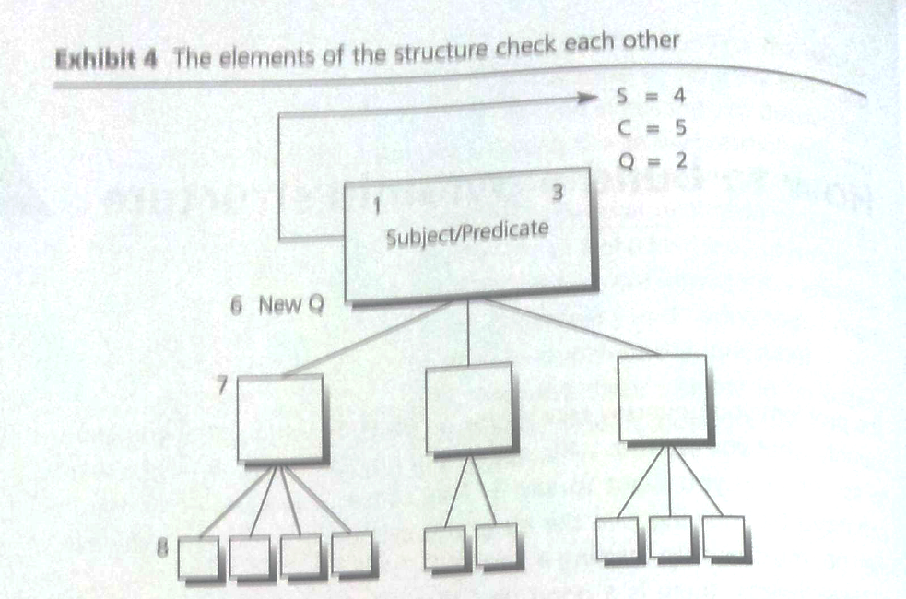
It is generally easier to start at the top and work down because you begin by thinking about the things that it is easier for you to be sure of – your subject and the reader’s knowledge of it, which you will remind him of the introduction. However, you don’t want to sit down and begin writing the opening paragraph of the introduction. Instead, you want to use the structure of the introductory flow to pull the right points out of your head, one at a time. Follow this procedure –
Fill the top box
- What Subject are you discussing?
- What Question are you answering about the Subject in the reader’s mind?
- What is the Answer?

Match the Answer to the introduction
- What is the situation?
- What is the Complication?
- Do the Question and Answer still follow?

Find the Key Line
- What New Question is raised by the Answer?
- Will you answer it deductively or inductively? For Key Line, it should be better in inductive.
- If inductively, what is your plural noun?

Structure the support points
- Repeat the question/answer process at this level.

- Draw a box. This represents the box at the top of your pyramid. Write down in it the subject you are discussing.
- Decide the Question. Visualize your reader. To whom are you writing, and what question do you want to have answered in his mind about the Subject when you have finished writing?
- Write down the Answer, if you know it.
- Identify the Situation. Next, you want to prove that you have the clearest statement of the Question and the Answer that you can formulate at this stage. To do that, you take the Subject, move up to the Situation, and make the first non-controversial statement about it you can make. What is the first thing you can say about it to the reader that you know he will agree is true – either because he knows it or because it is historically true and easily checkable? For the purposes of working out your thinking, you need only get clear the essence of the point of the paragraph – the importance of what you are addressing, the importance of what you are doing.
- Develop the Complication. Now you say to yourself, ‘so what?’ This should lead you to think of what happened in that Situation to raise the Question. Something went wrong, perhaps, some problem arose, or some logical discrepancy become apparent. What happened in the situation to trigger the question?
- Recheck the Question and Answer. The statement of the Complication should immediately raise the Question you have already written down. If it does not, change it to the one it does raise. Or perhaps you have the wrong Complication, or the wrong Question, and must think again.
- Spell out to support each point. After determining that these points are the right points and in a logical order, you can move down and spell out what you need to say to support each one. In the case of so short a document, however, you can probably get away with assuming they are easily available in your mind and will come to you as you get to each section to write it.
The purpose of the entire exercise is to make sure you know what Question it is you are trying to answer. Once you have the Question, everything else falls into place relatively easily.
As you can see, the technique has forced the writer to draw from his mind only the information that will be relevant to the reader’s question. But in doing so, it has helped push his thinking to deal fully with the question. And of course, if he follows the top-down order of presenting the ideas in writing, the entire message will be remarkable easy for the reader to absorb.

The bottom-up approach
Perhaps you can’t decide precisely what your Subject is, or the Question isn’t clear to you, or you can’t sort out what the reader does and doesn’t know for sure. In such cases, simply move down to the Key Line level. If you can think of any Key Line points, fine; but often you won’t be able to. Do not despair. You can work out the ideas from the bottom up by following a 3-step process.
- List all the points you think you want to make with number, e.g., Problems and Solutions, Causes and Effects.
- Work out the relationships between them by number in diagrams.
- Draw conclusions.

Whether the reader agrees on the points, you must present clearly. If your entire thinking is not clear to the reader in the first 30 seconds of reading, you should rewrite. The rest of the document exists only to explain or defend what you have already stated – which is assumed to have no important points by the reader’s mind naturally.
In addition, the headings serve to highlight the major points of the structure so that the reader can quickly pick up the general thrust of your subordinate arguments if the document is lengthy one, make sure the headings reflect ideas, rather than categories. Never have a heading called ‘Findings’ or ‘Conclusion’ for example, such headings have no scanning value.

Caveats for beginners
- Always try top-down first. The minute you express an idea in writing, it tends to take on the most extraordinary beauty. It appears to have been chiseled in gold, making you reluctant to revise it if necessary. Consequently, never begin by just dictating the whole document ‘to get it all down’, on the assumption that you can figure out the structure more easily afterwards. The chances are you’ll love it once you see it typed, no matter how disjointed the thinking really is.
- Use the Situation as the starting point for thinking through the introduction. Once you know what you want to say in the bulk of the introduction – Situation, Complication, Question and Answer – you can place these elements in any order you like as you write, depending on the effect you want to create. The order you choose affects the tone of the document, and you will no doubt want to vary it for different kinds of document. Nevertheless, begin your thinking with the Situation since you’re more likely to able to think up the correct Complication and Question following that order.
- Don’t omit to think through the introduction. Very often you’ll sit down to write and have the main point fully stated in your head, from which the Question is obvious. The tendency then is to jump directly down to the Key Line and begin answering the New Question raised by the statement of the main point. Don’t be tempted. In most case, you will find that you end up structuring information that properly belongs in the Situation or Complication, and therefore forcing yourself into a complicated and unwieldy deductive argument. Sort out the introductory information first so that you leave yourself free to concentrate solely on ideas at the lower level.
- Always put historical chronology in the introduction. You can’t tell the reader ‘What happened’ in the body of the document, to let him know the facts. The body can contain only ideas, and ideas can relate to each other only logically. This means that you can talk about events only if you are spelling out cause-and-effect relationships, since these had to be discovered through analytical thinking. Simple historical occurrences do not exist as the result of logical thought, and therefore cannot be included as ideas.
- Limit the introduction to what the reader will agree is true. The introduction is meant to tell the reader only what he already knows. Sometimes, of course, you won’t know whether he knows something; at other times, you may be certain that indeed he does not know it. If the point being made can be easily checked by an objective observer and deemed to be a true statement, then your reader can be presumed to ‘know’ it in the sense that he will not question its truth.
- Be sure to support all Key Line points. An idea must be supported until you have answered all the questions likely to be raised by it. Naturally, not every point needs the same depth of support. At the Key Line level, however, all points must have at least one level of support. This is particularly true of the ‘therefore’ point in a deductive argument. If you find yourself with no need to support the final point, then you have overstructured your argument and probably need only an inductive grouping.

Chapter 4 Fine points of introductions
Thinking through the introduction is the key step in discovering the ideas that must be presented in a document. By summarizing what the reader already knows, the introduction establishes the relevance of the question to which your document will give him the answer. You can then devote your energies to answering it. However, finding the structure of the introduction can be relatively complex and time-consuming activity.

Initial introductions
The initial introduction can be thought of as a circle around the top of your pyramid, outside the structure of the ideas you are presenting. It always tells the reader a story he already knows, in the sense that it states the Situation within which a Complication developed that raised the Question to which the document is giving the Answer.

Why a story?
The reader has a multitude of jumbled and unrelated thoughts in his head, most of which are on other subjects, and all of which are very dear and interesting to him. To push these thoughts aside and concentrate only on the information you present, with no prior conviction of its interest to him, demands real effort. He will be pleased to make that effort only if there is a compelling enticement for him to do so.
Even if he is quite eager to know what your document contains, and convinced of its interest, he must still make the effort to push aside his other thoughts and concentrate on what you’re saying. A foolproof device of this sort is the lure of an unfinished story. For example, by specific time and place, you can rivet the reader’s mind, control where it goes. That’s what you should do in an introduction. You want to build on the reader’s interest in the subject by telling him a story about it. Every good story has a beginning, a middle, and an end. It establishes a situation, introduces a complication, and offers a resolution. The resolution will always be your major point since you always write either to resolve a problem or to answer a question already in the reader’s mind.
If you want to tell the reader a really good story, you tell him one he already knows or could reasonably be expected to know if he’s at all well informed. Of course, this approach enables you to tell him things with which you know he will agree, prior to your telling him things with which he may disagree. Easy reading of agreeable points is apt to render him more receptive to your ideas than confused plodding through a morass of detail.

How long should it be?
The introduction should be long enough to ensure that you and the reader are ‘standing in the same place’ before you take him by the hand and lead him through your thinking. Generally, this means two or three paragraphs. The Situation and the Complication can each be if three or four paragraphs, but never more than that. It can’t take very much to remind someone of what he already knows. If you find yourself littering the introduction with exhibits, you can be sure that you are overstating the obvious.
The length of an introduction is not necessarily related to the length of the writing to follow. Rather, it is related to the needs of the reader. What does he have to be told not only to comprehend fully the significance of your main point but also to want to read on to learn how you arrived at it?
By contrast, the introduction can also be as short as a sentence: ‘In your letter of January 15 you asked me …’The closer you are in your everyday dealings to the person to whom you are writing, the shorter the introduction can get. But it must say enough to remind the reader of this Question.

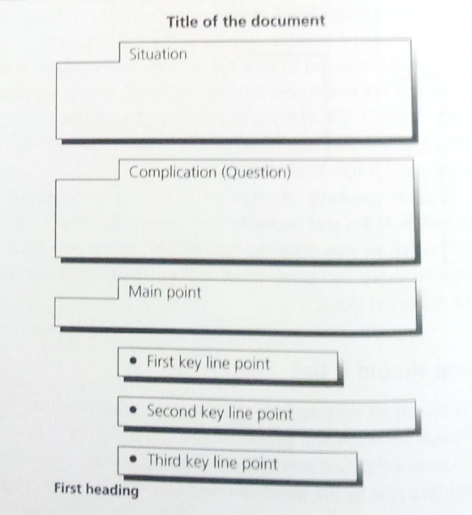
Where do you start the situation?
You begin writing the Situation by making a statement about the subject that you know the reader will agree with because you are telling him something that he already knows. If you find you can’t make a statement about the subject, then either you have the wrong subject, or you’re starting in the wrong place to talk about it.
Set out the Key Line points at the beginning
When you can readily the reader by name, as in a letter or memorandum, determining where to start is usually straightforward. You start the point where you can make a self-sufficient and noncontroversial statement about the subject – self-sufficient in the sense that no previous statement is needed to make the precise meaning of this one clear, and noncontroversial in the sense that you can expect him automatically to understand it and agree to it.
If you are writing a report for wide circulation, however, or a magazine article or a book, the job is not so much to remind the reader of the question as to plant one. Here getting started is a bit more difficult. Assume that your readers are moderately well informed and present an explanation of what is already generally accepted knowledge on the subject. By arranging known material in a narrative form, and usually in a way that they haven’t thought about it before, you inspire your readers to ask the question you wish to address.
The key characteristic of all opening Situation sentences is that they leave you expectant for further information – and that is what qualifies them to be openers. Each one establishes the base for a story to come.

What’s a complication?
The Complication of the introduction is not a complication in the everyday sense of the word; it is the Complication to the story. It describes an alteration to a stable situation, rather than a problem per se.
Situation | Complication | Question
Recognized stable situation | Something went wrong | What do we do?
 | Something could go wrong | How can we prevent it?
 | Something changed | What should we do?
 | Something could change | How should we react?
 | Here’s what you might expect to find in it | Do we find it?
 | Here’s someone with a different point of view | Who is right?
 | In this situation, we have three alternatives | Which one should we take?

Why that order?
The situation-complication-solution form of the introduction is essential. The order of the parts can be varied to reflect the tone you want to establish in the document.
- Considered: situation-complication-solution
- Direct: solution-situation-complication
- Concerned: complication-situation-solution

What about the key line?
The key line not only gives the answer to the new Question raised by the statement of your Main Point, but it also indicates the plan of the document. If it is a lengthy one, you will want to set the points out in the middle of the pages. You can then put a heading to represent the first point and start writing.
Setting the points out enables the reader to get your entire thinking in the first 30 seconds or so of reading. Since anything that follows will serve only to explain or defend these points, you have courteously put the reader in the position of being able to determine whether he needs to go on or ready to accept your conclusions as they stand. In any case, he now knows what to expect and can read with a greater sense of ease.
If the document is a short one, with only a paragraph or two to support each section, you do not of course want to set out the points and then repeat them in headings. In such cases, use the points as topic sentences to your paragraphs and underline them so that they jump out at the reader.
Remember that the Key Line points should be expressed as ideas, it is not sufficient to write an introduction like the following -
This memorandum describes the project team approach to identifying and achieving significant profit improvements. It is organized in six sections as follow:
Background
Principles of project team approach
What project work is
How the program is organized
Unique benefits and specific results
Prerequisites for success

Here the setout of the points is useless in the sense of conveying the message of the document to the reader. It simply forces on the reader a string of words that he can’t put into perspective – mere excess baggage that wastes his time and delays his understanding.
As a rule of thumb, you never want to have a section labelled ‘Background’ (or ‘Introduction’) because the major point it expresses will not be on the same level of abstraction as the other points that follow. In the example above, because the writer is writing about subjects instead of about ideas, the ideas likely to be behind the subjects will probably not form a clear argument, either inductive or deductive.
Indeed, one suspects that the ideas in the various sections are badly jumbled as they stand, for example, the ‘Unique benefits and specific results’ should probably be discussed under the ‘Principles of project team approach’. Never write about categories, only about ideas.
If you are beginning to think that it might be difficult to write a good introduction, you are right. More botches are made of introductions than of any other part of a person’s writing. However, by reading enough examples you should get a sense of when an introduction sounds ‘right’ and keep working at yours until they do.

In summary
It is important to devote a good idea of thought to ensuring that you write a good introduction. For as you can gather from the examples, a good introduction does more than simply gain and hold the reader’s interest. It influences his perceptions.
The narrative flow lends a feeling of plausibility to the writer’s particular interpretation of the situation, which by its nature must be a biased selection of the relevant details; and this feeling of plausibility constricts the reader’s ability to interpret the situation differently. It also gives a sense of inevitable rightness to the logic of the writer’s conclusion, making the reader less inclined to argue with the thinking that follows. Finally, it establishes the writer’s attitude to the reader as considerate one of wanting him clearly to understand the situation – to see behind the language to the reality it represents. To emphasize the theory behind writing good introductions:
- Introductions are meant to remind rather than to inform. This means that nothing should be included that would have to be proved to the reader for him to accept the statements of your points – i.e., no exhibits.
- They should always contain the three elements of a story. These are the Situation, the Complication, and the Solution. And in longer documents you will want to add an explanation of what is to come. The first three elements need not always be placed in classic narrative order, but they do always be included, and they should be woven into story form.
- The length of the introduction depends on the needs of the reader and the demands of the subject. Thus, there is scope to include whatever is necessary for full understanding: history or background of the problem, outline of your involvement in it, any earlier investigations you or others have made and their conclusions, definitions of terms, and statements of admissions. All these items can and should be woven into the story.

Some common patterns
Here are five patterns repeated most often, drawn from both business and consulting.

Directives
Directives reflect a situation in which you are writing to tell someone else to do something. In this case, you will be planting the question in the reader’s mind, rather than reminding him of it.

S = We want to do X
C = We need you to do Y
Q = How do I do Y?
S = You do X
C = Must do in Y way
Q = What is Y way

Requests for funds
Those the reader’s Question is always ‘Should I approve the request?’ and here again the Question would be implied rather than stated, as would the Complication. That is, you would have a formal structure that said:
S = The Consumer Group wishes to purchase a Wang System 25, together with four CRTs and three printers, at a cost of $__.
C = (They cannot purchase without your approval)
Q = (Should I approve?)
Only the Situation would be stated in the writing, and then the pyramid structure would tell the reader to approve the purchase for some set of relevant reasons.

‘How to’ Documents
S = Must do X activity
C = Not setup to do so
Q = How do we get setup
Suppose you have a company whose market forecasting system gives inaccurate forecasts, and they want you to tell them how to make it give accurate ones. The structure is always:
S = You present system is X
C = It doesn’t work properly
Q = How change to make it work properly?
The trick here is to begin with your thinking by literally laying out the present process as the do it now. Then lay out the process as you think it should be done. The process must be drawn into diagrams vividly. You cannot be sure your thinking is complete and that you have not left anything out unless you make the actual step-by-step comparison. Then the differences between the first structure and the second tell you what the steps on your Key Line must be. Many examples of incomplete thinking are due to unclear in visualizing the processes.

Letters of Proposal
These documents are the lifeblood of consulting and have thus had a good deal of thought lavished on them over the years by consulting firms.
S = You have a problem
C = You have decided to bring in an outsider to solve it
Q = (Are you the outsider we should hire to solve it?)
The Answer to the Question is always ‘Yes’. While the Key Line should be a approach that contains less than 5 steps where you specify what you will take to solve the problem. These steps must be stated in end-product terms and will serve to define the major phases of the study, with the specific end products to be expected at the end of each phase.
Don’t describe ‘We understand the problem’ or ‘We have good people to work on it’, as they belong to the situation or qualifications.

Progress Reviews
These are usually the formal communications one schedules with the client at the end of each phase of the study, leading up to the final report. After the first one, the structure is always the same.
S = We told you X
C = You asked us to investigate Y, which we have done
Q = What did you find?

What must be apparent by now from these examples is that the pivot on which your entire document depends is the Question, of which there is always only one to a document. On occasion you will not be able to determine the question easily just by thinking through the introduction. In that case, look at the material you intend to include in the body. Whenever you have a set of points you want to make, you want to make them because you think the reader should know them. Why should he know them? Only because they answer a question. Why would that question have arisen? Because of his situation. So that by working backward you can invent a plausible introduction to give your question a logical provenance.

Transitions between groups
Once you have written your introduction and moved into the body of your document, you must pause periodically to let the reader know where you’ve been and where you next plan to go – at either the end or the beginning of each major grouping. In doing so, you want to make your progress from point to point seem smooth and nonmechanical. Thus, you do not want to say such things as –
This chapter has looked at the need for priorities. The next chapter looks at how these priorities should be set.
In other words, you do not want to relate what two chapters or sections do, you want to relate what they say – their major ideas. And you want to do it in such a way that you seem to be looking in two directions at once – back to what has been said and forward to what is to be said. If you make this pause at the beginning of a chapter, section, or subsection, you should use the technique of referencing backward. If the chapters or sections are long ones, then you will probably find it clearer to pause at the end and make it a summary before going on.

Reference backward
The technique of referencing backward consists simply of picking up a word or a phase or the main idea of the preceding portion of the pyramid that you are linking and using it in your opening sentence. You are probably familiar with the technique in transitions between paragraphs.
The point is to make the transitions unobtrusive yet clear, primarily through picking up the key word or phrase and carrying it forward. You are, of course, carrying it forward to connect with the major point of the next section, which has already been introduced briefly in the ‘explanation’ part of your original introduction. Thus, here you need not lead up to it with a ‘Story’ as you did previously.

Summarizing
Sometimes the chapter or section will be extremely long or complicated, in which case you will want to stop and summarize completely before going on. Concluding summaries of this sort are not difficult to write if you keep in mind that they are meant to restate, as adroitly as possible, the principle matter and tone of the preceding text. Since you have these in front of you in your pyramid, all you are doing is pulling them together again for the reader.
In all this positioning, the intention is to make the job of thinking required of the reader as easy as possible. He is, after all, rarely trained in analysis and reflection, and can have nowhere near the understanding of the subject you have even if the subject is his own company. You and he are not peers in interpreting your thinking on the subject.
Thus, you must expect that his mind will not be precisely where you want to be, in terms of understanding, as you finish one lengthy group of points and prepare to go on to the next. Your transitions are meant to grab his mind, as it were, and pull it back to where it belongs if he is to comprehend what you are trying to say. This is essentially an exercise in good manners, provided it is done gracefully and only where needed.

Concluding
If you write a proper introduction and structure the body of your document to obey the pyramid rules, you should not need a concluding statement. You have clearly stated your reader’s question at the beginning and answered it fully with impeccable logic. Nevertheless, you may feel a psychological need to end gracefully rather than simply to stop writing. The obvious procedure at the end of a longer document is to signal the end by putting a line of asterisks in the middle of the page, which sometimes called a ‘sunset’. You then begin your last paragraph with the words, ‘In conclusion …’ and re-emphasize your main point. However, if you favor this approach you want to avoid merely making a lame restatement of what you have already made abundantly. Rather, you want to find a compelling set of words that not only sums up for the reader what you have been saying, but also produces an appropriate emotion in him about it. At last, that is Aristotle’s advice about what to do in a conclusion.
That there is an ‘appropriate emotion’ for the end of a business document may be open to question, but I should think the major feeling you want to leave with your reader is that of a need and desire to act. Consequently, you want to give him some indication of what he is to think about or can do with the new knowledge the now possesses as a result of his reading.
As you may have gathered from my tone, I do not encourage most people to write concluding paragraphs because they are so difficult to do well. Simple pragmatism dictates that you do without. However, there is an occasion on which you will need a concluding section, and that is when you are dealing with future actions. For example –
Next Steps:
- Call the man who owns it and ask him to launch.
- Call the bank to make sure the money for purchase will be available when you need it.
- Reconvene the Acquisitions Committee to handle the administrative details.

Clearly, your reader is not going to say to you, ‘Why do I ask him to lunch, why can’t I ask him for dinner?’ These are self-evident points and can be accepted without demur. If, on the other hand, they were points that did raise questions in his mind, then you would have to include them in the body of your text and make certain they fit horizontally and vertically with everything else you’re saying.

Chapter 5 Deduction and induction: the difference
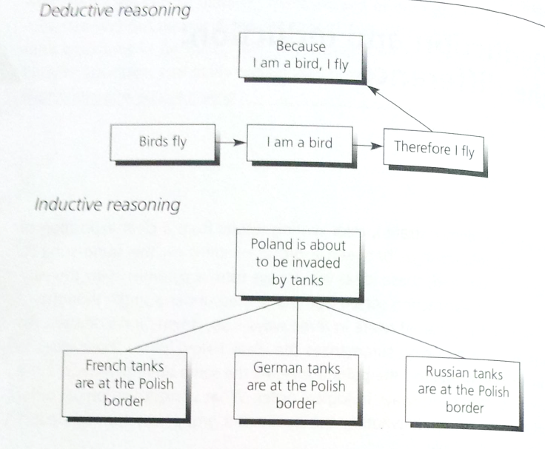
Clear writing results from a clear exposition of the extract relationships between a group of ideas on the same subject. Properly organized, these ideas will always form a pyramid, with the various levels of abstraction sorted out and related under a single thought. Ideas in the pyramid relate in three ways – up, down, and sideways. An idea above a grouping summarizes the ideas below, while these ideas in turn explain or defend the point above. At the same time, the ideas in the grouping match sideways in logical order. What constitutes logical order differs depending on whether the pyramided group was formed deductively or inductively. These two forms of reasoning are the only patterns available for establishing logical relationships between ideas. Consequently, an understanding of how they differ and what their rules are essential to being able to sort out your thinking and express it clearly in writing.

Deduction presents a line of reasoning that leads to a ‘therefore’ conclusion, and the point above is a summary of that line of reasoning, resting heavily on the final point. Induction defines a group of facts or ideas to be the same kind of thing, and then makes a statement or inference about the sameness. The deductive points derive from each other, the inductive points do not.

Deductive Reasoning

How it works
Deductive reasoning is usually described as taking the form of a syllogism – an argument in which a conclusion is inferred from two premises, one major and one minor.
- Make a statement about a situation that exists in the world.
- Make another statement about a related situation that exists in the world at the same time. The second statement relates to the first if it comments on either its subject or its predicate.
- State the implication of these two situations existing in the world at the same time.
Sometimes you will find yourself wanting to skip a step and chain two or more deductive arguments together, since to put in every step would take too long and sound pedantic. This chaining of arguments is perfectly permissible, provided that your reader is likely to grasp and agree with the missing steps.
But it could be boring to read if you put in every step, they make a mystery story out of what should be a straightforward point.

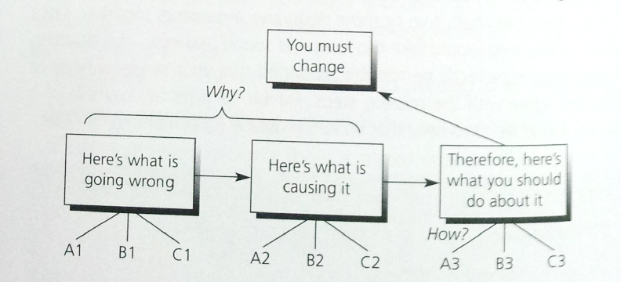
When to use it
This leads me to urge that, on the Key Line level, you try to avoid using a deductive argument, and strive instead always to present your message inductively. Because it is easier on the reader.
Let’s look at what you force the reader to do when you ask him to absorb a deductively organized report.
Suppose you wish to tell him that he must change in some way. Your argument would look something like this:

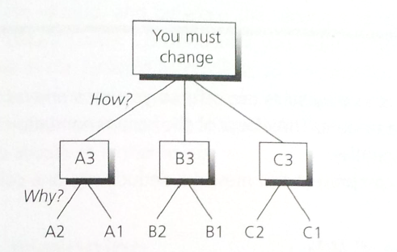
To absorb your reasoning, the reader must first take in and hold the A-B-Cs of what is going wrong. Then you ask him to take the first A of what is going wrong, bring it over and relate it to the second A of what is causing it, and then hold that in his head while you make the same match for the Bs and Cs. Next you ask him to repeat the process. Not only do you make the reader wait a very long time to find out what he should do, you also force him to re-enact your entire problem-solving process before he receives his reward. It is almost as if you’re saying to him, ‘I worked extremely hard to get this answer, and I am going to make sure you know it’. How much easier on everybody were you simply to present the same message inductively:

Instead of answering the ‘Why’ question first and the ‘How’ question second, you simply reverse the order. And now, while you may indeed have deductive arguments at the lower levels, still you have answered the reader’s major question directly, with clear fences in your thinking between subject areas, and all information on each subject in one place.
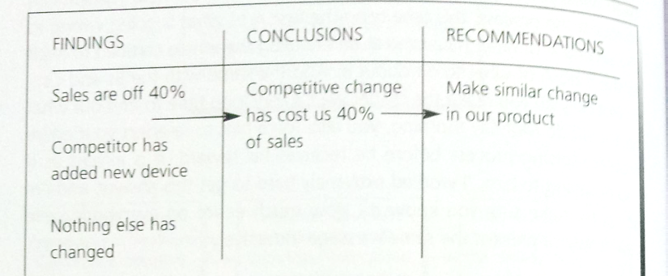
To explain it another way, at the end of the problem-solving process, you will have come up with a set of ideas that can be sorted onto a Recommendation Worksheet.
This permits you to visualize the fact that you have gathered findings that led you to draw conclusions from which you determined recommendations. In writing to recommend action, you will never give findings that do not lead to conclusions, nor state conclusions that are not based on findings. Nor will you have conclusions that do not lead to recommendations, nor recommendations that are not based on conclusions. One conclusion can lead to several recommendations, and several conclusions can lead to one recommendation, but there must always be a connection.
The conclusions generally state the problem that the recommendations solve. Consequently, the effect of the recommendation is to solve the problem you concluded was there. Sometimes the issue would be whether it is better to tell the reader why he should change and then how to go about it, or that he should change and why. As a rule of thumb, it is always better to present the action before the argument, since that is what the reader cares about. But there are two conditions in which the argument might be more important to the reader than the action:
- If he is going to disagree strongly with your conclusion, so you must prepare him to accept it.
- If he is incapable of understanding the action without prior explanation, as in a paper on how to do risk analysis, so that you must give him the reasoning that underlies it.
Consequently, you want to push deductive reasoning as low in the pyramid as possible, to limit intervening information to the minimum. At the paragraph level deductive arguments are lovely and present an easy-to-follow flow. But inductive reasoning is always easier to absorb at higher levels.

Inductive reasoning
Inductive reasoning is much more difficult to do well than is deductive reasoning since it is a more creative activity. In inductive the mind notices that several different things are similar in some way, bring them together in a group, and comments on the significance of their similarity. This bring us to the two major skills one must develop to think creatively in the inductive form:
- Define the ideas in the grouping
- Identifying the misfits among them

How it works
The key technique is to find one word that describes the kind of ideas in your grouping. This word will always be a plural noun, because
- Any ‘kind of’ thing will always be a noun
- You will always have more than one of the ‘kind of’ idea in your grouping.
The next step is always to check your reasoning, and this is done by questioning from the bottom up. The statement shouldn’t be too high a level of abstraction, the statement should be only about the points grouped below specifically.

How it differs
If you are thinking deductively, your second point will always comment on the subject or predicate of the first. If it does not so comment, you should be able to classify it by the same plural noun as the first, to test that you have a proper inductive grouping. Placing ideas in classes is defining them by a plural noun, and you know that that is induction.
Note that, with inductive ideas you generally hold the subject constant and vary the predicate or hold the predicate constant and vary the subject.
It is interesting to note that whether you couple the ideas to form an inductive grouping or the beginning of a deductive line of reasoning, your mind automatically expects either a summarizing statement or a ‘therefore’ point. This expectation of the mind for deductive and inductive arguments to be completed often leads the reader to project his thinking ahead, to formulate what he thinks your next point will be. If his is different from yours, he can become both confused and annoyed. Consequently, you want to make sure that he will easily recognize the direction in which your thinking is trending by giving him the top point before you state the ideas grouped below.

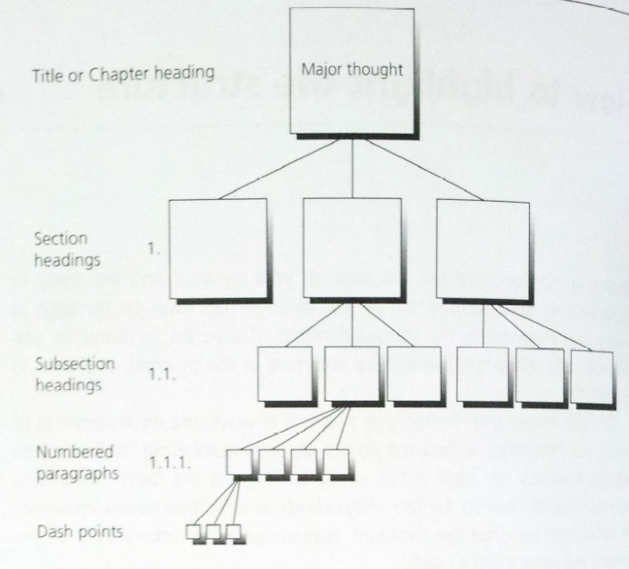
Chapter 6 How to highlight the structure
Once you have worked out the logic of your pyramid and are ready to begin writing, you want to be sure you arrange your ideas on the page in way that emphasizes the various divisions of thought. In doing so, you will naturally reflect the hierarchical structure of the pyramid. You can reflect this hierarchy in a variety of ways, the most common of which are headings, underlined points, decimal numbering, and intended display. Whichever format you choose, remember that your objective is to make comprehension easier for the reader. This means that the format must be applied properly to reflect the levels of abstraction in your argument. To give the desired appearance without the proper content can cause confusion.

Headings
Each heading should represent a division of thought.
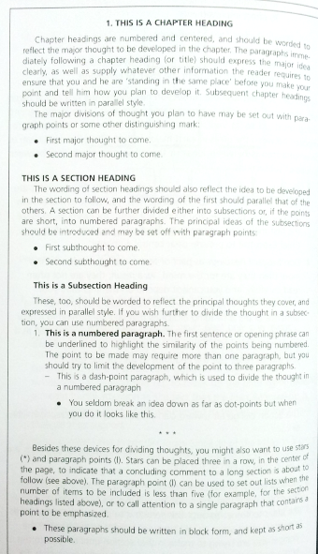
- Never use only one of any elements. Since the headings indicate levels of abstraction in the pyramid, you can never have only one item at each level. Thus, you can never have only one major section, or one subsection, or one numbered paragraph, or one dash point. A heading is meant to call attention to the fact that the idea it represents is one of a group, all of which are needed to understand the overall thought they support.
- Show parallel ideas in parallel form. Since all the ideas in a group are the same kind of idea, you want to emphasize the sameness by using the same grammatical form for the wording of each heading, etc. Consequently, if the first idea in a group of major section headings begins with a verb, all the rest must as well; if the first idea in a group of subsection headings begins with an ‘ing’ word, so should all the others.
- Limit the wording to the essence of the thought. The headings are meant to remind, not to dominate. Thus, you want to make them as concise as possible.
- Don’t regard headings as part of text. Headings are for the eye more than they are for the mind. As a result, they are not often read carefully, and you cannot depend on them to carry your message. Accordingly, you need to make sure that your opening sentence under a heading indicates that you are tuning to a new topic. In fact, your entire document should be able to be read as a smooth-flowing piece without the headings. By the same token, you should never use the headings as part of the text. This rule does not apply to numbered paragraphs, which are meant to be read as part of the text.
- Introduce each group of headings. In doing so, you want to state the major point that the grouping will explain or defend, as well as the ideas to come. To omit this service is to present the reader with a mystery story, since he will then not able to judge what the point is you are trying to make in that section until he gets to the end – and by then he may well have forgotten the beginning. For this reason, you should never have a major section heading begin immediately after the title, nor should you ever have a subsection heading begin immediately after the section heading.
- Don’t overdo. This is perhaps the most important rule of all. You want to use headings only if they are going to clarify your meaning – if they are going to make it easier for the reader to keep the subdivisions of your thought in his head. Often it is not necessary of useful to have any divisions below the major section headings.
If you formulate your headings properly, they will stand in the table of contents as a precis of your report – another extremely useful device for the reader in trying to come to terms with your thinking.

Underlined points
Another popular approach is literally to show the hierarchy of ideas by underlining the entire statement of the support points below the Key Line level. Lower-level support points are also stated in their entirely, but distinguished by form and indention.
The purpose of this format is to provide speed and ease in reading. The theory is that the reader should be able to speed through if he wishes, reading only the major underlined points, and in that way comprehend the entire message.
- You must be absolutely disciplined in applying question/answer logic. Points below must directly answer the question raised by the point above, and no more. There is no room in this format for graceful liaisons of language or attempts at amplification. Such things destroy the clean, stark presentation of the logic. If you must amplify or give background, you will have to do so in the introductory or concluding paragraphs.
- You must be careful to word the points so that they state their message as sparsely as possible. It destroys the ease with which the logic can be comprehended if the reader must wade through 30 words before he grasps the point. If you find yourself with more than a dozen words, or more than one subject and predicate, think again.
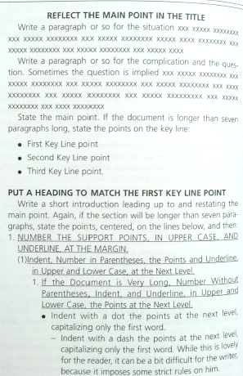
- You must be totally ruthless in limiting your points to the outline of your deductive or inductive argument. Most people ignore this requirement and end up simply listing points, without regard to the niceties of either introduction or deduction. You know that there are never more than four points in a chained deductive argument, and never more than five in an inductive one. If you find yourself going beyond that, the likelihood is that you have overlooked an opportunity to group and should rethink what you are saying.

Decimal numbering
Many companies and most government institutions like to use numbers rather than headings to emphasize the subdivisions of a document, and some go so far as to number every paragraph. This approach is claimed to have the advantage that any single topic or recommendation can be easily and precisely referred to.
However, frequent index numbers do tend to interrupt the reader’s concentration on the content of the document, or on any section of it.
If you decide that you prefer to have numbering because of its value as a quick guide, you would probably be wise to use it in conjunction with, rather than as a replacement for, headings. The headings have the value of enabling the reader to pick up the gist of the ideas quickly as he reads. And they are quite useful in refreshing his memory if he finds he must go back to the document several days after his initial reading.
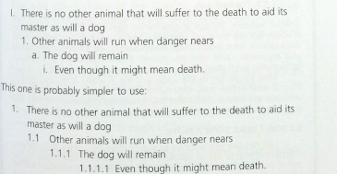
In addition, you will usually find that saying 'In Section 4.1 on manufacturing profits...' is clearer as a reference in jogging someone’s comprehension and thinking than is saying only ‘In Section 4.1’. In the former case, the person has the general idea in mind as he turns to the specific reference; in the latter, he must get to it before he can begin to think about it.
These examples show the relationships of the numbered levels to each other, rather than the actual form they should take. The form should reflect the actual divisions of thought in the piece of writing. Accordingly, you would not number the paragraphs in initial introductions, in concluding summaries, in linking comments, or in the introduction to subpoints.

Indented display
Sometimes your document will be so short that neither headings nor decimal numbering would be appropriate to highlight the divisions of your thinking. Nevertheless, you will still be dealing with groupings of ideas, and you will want to highlight them in some way. Groups of points supporting or explaining an overall idea are always easier for the reader to absorb if they are set off to be easily distinguishable as a group.

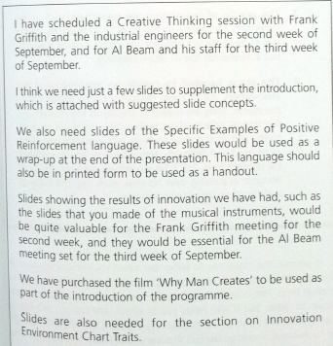
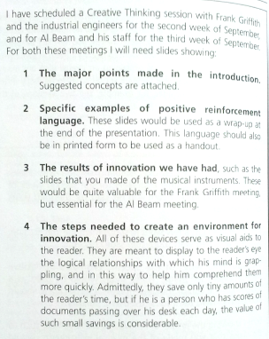
The first version is perfectly clear as it stands; but the approach used in the second version makes the point literally ‘jump out’ at the reader.

In general, the major rule to remember when you set your ideas off in this way is that you want to be sure to express them in the same grammatical form. Not only does this usually save words and make the ideas easier to grasp, but it also helps you to check whether you are saying clearly what you mean to say.
Whether the memorandum is long or short, the visual arrangement of groups of ideas to set off their similarity to each other as ideas will always make them easier to comprehend. As with headings, however, one set of indented groupings per memorandum is enough; otherwise, the visual effect is lessened.

Part 2 Logic in Thinking
You can generally identify your Subject without much effort, determine the reader’s Question, think though the Situation and the Complication, and proceed with a listing of your major points. With your title and major side headings decided, you can then settle to the serious business of putting it all into writing. But no matter how carefully you have done your thinking in coming up with this initial structure, you are unlikely to produce a first draft that is perfectly logical and obeys all the rules. Points that seem to group logically in pyramid form often prove to have only a tenuous connection when clothed in prose. And watertight arguments have been known to spring gaping holes when you try to marshal valid support.
Unfortunately, you are unlikely to be able to see these flaws without making a special effort to do so. Once you put ideas in writing, they take on an incredible beauty in the author’s eyes. They seem to glow with a fine patina that you will be quite reluctant to disturb.
The most efficient way to overcome this psychological impediment is to have a checklist of rules you apply every grouping in the structure, so that you are forced to look at it critically. In this way you parental pride is backed into abeyance, and you can be objective about what you see. This approach applies equally effectively, of course, to reading someone else’s draft.
There are essentially four sets of such rules available to help you focus your critical faculties:
- You can question the general order of the ideas in a grouping.
- You can question their source in your problem-solving process.
- You can question your summary statement about them.
- You can question the prose in which you express them.

Chapter 7 Questioning the order of a grouping
You must understand that ideas grouped together in writing are never brought there by chance. They are always picked out of your mind because it sees them as having a logical relationship. To see such relationships, the mind must have performed a logical analysis. In that case, the order you choose should reflect the analytical activity that your mind performed to create the grouping. The mind can perform only three analytical activities of this nature.
- Time order: It can determine the causes of an effect. Whenever you make statements in writing that tell the reader to do something, you do so because you believe the action will have a particular effect. When several actions are together required to achieve the effect, they become a process or a system, the set of causes that in concert create the effect. The steps required to complete the process or implement the system can only be carried out one at a time, over time. Thus, a grouping of steps that represents a process or system always goes in time order.
- Structural order: It can divide a whole into its parts. You are familiar with this technique in creating organization charts or picturing the structure of an industry.
- Ranking order: It can be classify like things together. Because they are different, you rank them in the order in which they possess to the greatest degree whatever characteristic made you identify them as problems in the first place.
These orders can be applied singly or in combination, but one of them must always be present in a grouping.

Time order
What you are doing in a time-ordered grouping is spelling out the steps a person must take to achieve a particular effect, in the order in which he must take them.
Although it seems a simple discipline to impose, it is extraordinary how frequently people fail to impose it. Consequently, the most common logical flaw you are likely to find in a first draft is improper time groupings. The trick in sorting them out is to visualize yourself taking the actions in each case.
Ask yourself, ‘What would I do first if I were doing this? What second?’ etc. Answering the question can help you to uncover instances where your thinking has been incomplete, your logic confused, or your grouping false.

Incomplete thinking
Try the questioning of the order on this example -
Strategic planning involves the recognition of a timing cycle.
- Perception of need.
- Development of strategy for creating responsive product/service.
- Implementation.
- Market acceptance and high growth.
- Slower growth, the onset maturity.
- High cash generation.
- Decline/decay.
First you would perceive the need, then you would develop a strategy, then implement the strategy, then … Oops, here is a problem.
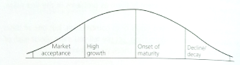
What the author appears to have done is to group three actions and four results. If you look at the results for a moment, you can see that he is reflecting the normal product life-cycle curve.
Thus, he must mean his fourth step to be something like ‘Track the market’s reaction’, with these points as the path of that reaction. We do have one point left over: high cash generation. This, however, is normally a characteristic of the onset-of-maturity phase, so does not belong in the list at all.

Confused logic
In this example –
However, business definition …
Relies heavily on creative processes.
Demand segmentation.
Supply segmentation.
Changes over time.
Early vs. late stages of life cycle.
Competitive dynamics.
Not necessarily unique in a given industry.
Influenced by marketer’s own strength vs. competition.
Whatever can he mean? Is it time order that he is talking about in carrying out the act of business definition: first you be creative, then you change then … No, that doesn’t make sense. What are the actions implied here? Segmentation, review for changes, assessment of competitive strengths. Now can you see an order?
Business definition requires careful analysis:
In defining the market segments.
In assessing your competitive position in each segment.
In tracking changes in position over time.

False grouping
It also lets you identify when you have brought ideas together that don’t belong in the grouping, as here:
The traditional focus of investment evaluation is to compare future returns and probable costs.
It is often technically unsound.
It rests on simplistic concepts.
It results in misleading prescriptions.
Are these ideas in order of importance? In time order? In structural order? Or in none of the above? If you look critically, you can see that the third idea is the effect of the other two. Thus, he seems to be saying:
Evaluating investments by comparing future returns to probable costs results in misleading prescriptions.
The concept itself is simplistic.
Its application is often technically unsound.
The order is time order, in the sense that you must have the concept before you can apply it badly. Once you impose a logical order on the ideas, you are then able to check that the thinking is complete. You cannot do so while the concept itself is unclear.
Sometimes you will find that time order is imposed on an existing structure, so that the structure dictates the number and sequence of steps.

Structural order
It is the order that reflects what you see once you have visualized something – either by diagram or map, by drawing or photograph. The ‘something’ you visualize can be real or conceptual, an object or a process. It must have been properly divided to show its parts.

Creating a structure
When you divide a whole into its parts – whether it be a physical whole or a conceptual one – you must make sure that the pieces you produce are –
- Mutually exclusive of each other – NO OVERLAPS.
- Collectively exhaustive in terms of the whole – NOTHING LEFT OUT.
Which is MECE for mouthful reason. Structural order at its simplest means that you will describe the pieces of the structure as they appear on the diagram.
Forcing yourself to see an order, particularly if you are creating something new, permits you to check that you have been collectively exhaustive for your purpose.

Describing a structure
Once the structure is set up, one way to describe it is to follow it from the top down and from left to right, describe each part in the order in which it appears. Or you can describe it as one can view the subject, the eye would comprehend them as it began to look at the subject. The order that makes most sense is the order in which you would draw the elements on a blank sheet of paper if the elements are equally important and time order is not appropriate.

Imposing a structure
You can also use the concept of structural order to help you sort out faulty logic in a grouping. Suppose you had this set of steps presented to you for your approval:
The objectives for the assignment, as we understand them, are:
- To review and analyze field operations in maintenance and construction areas.
- To determine if adequate organizational and managerial flexibility exists to allow field engineers to properly respond to day-to-day operating problems and demands from the public.
- To review and analyze the areas of preliminary engineering, road and bridge design, environmental process, right-of-way acquisition and traffic management.
- To review and analyze the organization structure of the Department.
- To identify the strengths and weaknesses within each study area.
Why this order? Where did these ideas come from? First of all, you can see that point 5 does not go with the others because it refers to them all, so we can eliminate that. Then let’s see what subjects he’s talking about in the others:
- Maintenance, construction
- Day-to-day operations
- Preliminary engineering, road bridge and bridge design, environmental process, right-of-way acquisition, traffic management
- Organization structure
If we attempt to see them in terms of a process concerned with roadbuilding, etc. you would assume the steps involved would be these:
- Design
- Construct
- Operate
- Maintain
In that case, perhaps the author meant to say that the objective for the assignment would be to determine whether the Department is properly organized and managed to carry out its activities, of which there are four.

Ranking order
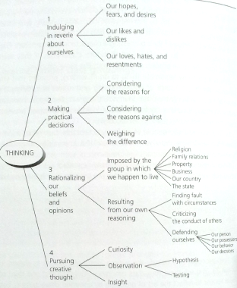
Ranking order is the order of importance. This is the order you impose on a grouping when it brings together a set of things you have classified as being alike because they posses a characteristic in common.

Creating proper class groupings
In classifying, you prove the classes are mutually exclusive by defining quite specifically what characteristic they have in common, and then searching your knowledge to make sure you have included in your grouping all known items with this same characteristic. Then you place them in the order of the degree to which each possesses the characteristic by which you classified it – presenting the strongest one first. The strongest-to-weakest order is clearer than the weakest-to-strongest order.
Classifying is a ubiquitous human habit. People classify everything as soon as they see it. They also consider ideas to be alike, classifiable. This is perfectly legitimate thing to do in writing, if you are clear about the source of your grouping and reflect accordingly the order it imposes. But often, the great pleasure authors feel in having thought up three or four points to include in a grouping prevents them from questioning the logic of its origin, the results turn to be perfectly acceptable but indiscriminate classifying. In such condition, there are flaws in what seems like proper class groupings. For example, from the chart of classifying thinking in a book, we see four class groupings. Only the first and third of these appear to reflect the act of grouping by common characteristic. The second and fourth present a process. The technique I use to determine its validity is to question its origin: 1) What does he label the point as? 2) Can I find anything more specifically the same about them? 3) Can I justify their order on that basis? 4) Are there any missing?
The point is that to check the thinking for completeness, you must be able to identify its source and make sure you have included all that the soruce produces. It will affect the way in which the inference you draw from the groupings is accepted as true by the reader. If overcomplete, your statement will not apply equally to the points below. If incomplete, someone else adding memebers to it could draw a different inference.
To repeat, groupings are not just drawn out the air, but reflect an analytical assessment that implies a strict order. You want deliberately to look for this order in every class grouping so that you can be certain you are saying what you mean.

Identifying improper class groupings
Suppose you came across this –
The traditional financial focus of investment evaluation results in misleading prescriptions for corporate behavior …
- Corporations should invest in all opportunities where probable returns exceed the cost of capital.
- Better quantification of future uncertainty and risk is the key to more effective resource allocation.
- Planning and capital budgeting are two separate processes; capital budgeting is a financial activity.
- Top management’s role is to challenge the numbers rather than the underlying thinking.
Now apparently these are the four misleading prescriptions that result from the traditional financial focus. More specifically, they are commonly believed ‘rules of thumb’ in corporations. But are they? If you reword them as results, they say:
- Encourage corporations to invest.
- Emphasizes quantification of uncertainty.
- Separates planning and capital budgeting.
- Leads top management to focus on the numbers.
All but the third can now be seen as part of a process of decision making. Which would dictate a different order, which in turn would lead to a clearer point at the top.
The traditional financial focus of investment evaluation can result in poor resource allocation decisions:
- Emphasizes quantification of future uncertainty and risk as the key to choosing among projects.
- Leads top management to focus on the numbers rather than the underlying thinking.
- Encourages investments in all opportunities where probable returns exceed the cost of capital, ignoring other considerations.
Very often, you will find yourself with several kinds of ideas whose class membership is not that easy to see at first reading.
Problems with sales and inventory system reports:
- Report frequency is inappropriate.
- Inventory data is unreliable.
- Inventory data is too late.
- Inventory data cannot be matched to sales data.
- People want reports with better formats.
- People want elimination of meaningless data.
- People want exception highlighting.
- People want to do fewer calculations manually.
The trick is to go though and sort them into rough categories, as a prelude to looking more critically later. You get the categories by defining the kind of problem they are discussing:
Timing
- Report frequency is inappropriate.
- Inventory data is too late.

Data
- Inventory data is unreliable.
- Inventory data cannot be matched to sales data.
- People want elimination of meaningless data.

Format
- People want reports with better formats.
- People want exception highlighting.
- People want to do fewer calculations manually
You have a double ordering task here. First, in what order do you put timing, data, and format? That depends on the process you think they reflect. Here we have two possibilities: we could be talking about the process of preparing the reports, or we could be talking about the process of reading the reports. If you are talking about preparing the reports, you would complain first about the data, then about the format, then about the timing, because that is the order in which the preparer would deal with them. On the other hand, if you are talking about reading the reports, you would complain first about timing, then about the format, then about the data, for the same reason.
How about ordering the ideas in each grouping? Under Timing, points 1 and 3 should probably be reversed, as you worry about lateness before you worry about frequency. Under Data, I should think you would complain first that a good deal of the data are meaningless, what is not meaningless is unreliable, and what is reliable can’t be matched. Process order again. Under Format, points 7 and 8 would be subsets of point 5, with the ‘fewer calculations’ probably coming before the ‘highlighting’.
A great value of the exercise has been to show that in some areas the thinking is incomplete, so that the author can review his analysis. Here is another example –
The causes of New York’s decline are many and complex. Among them are:
- Wage rates higher than those that prevail elsewhere in the country.
- High energy, rent and land costs.
- Traffic congestion that forces up transportation costs.
- A lack of modern factory space.
- High taxes.
- Technological change.
- The competition of new centers of economic concentration in the Southwest and the West.
- The refocusing of American economic and social life in the suburbs.
This is a good example of ‘truism’ in argument. What in effect the author is saying is:
- Everybody knows that there are lots of reasons for New York’s decline.
- Here are some of them.
- Therefore … (?) on to the next subject.
The problem with such ‘for instancing’ is that it cannot lead you logically to consider what you do about the problems. As a partial list it communicates nothing because you cannot draw a clear inference from it. Nevertheless, 8 points hardly seems partial. Is there any message at all? Where can you see some similarities?
Costs
- High wage rates.
- High energy, rent, land.
- High transportation.
- High taxes.

Unsuitability of area
- Lack of modern factory space to modernize into.
- Technological change (leading to need to modernize)
- Business associates moved to suburbs.

Alternative choice
- New centers in the Southwest and West.

Perhaps he means to be saying this:
The causes of New York’s decline reflect in part the growth of new business centers:
It has always been a high-cost city in which to do business.
More attractive areas are springing up in the Southwest and West.
Thus, when companies face the need to move, they choose to move south.

It is what an interested reader might glean from his listing. By pointing out what it does seem to be saying, you give the author the opportunity to rewrite it, to say more clearly what he does mean.

Just one more example, in that it is almost a free association of points. However, given our technique it is relatively easy to work out. And it does demonstrate that the author had a structure in his head before he began to write. He simply reflected his comprehension of it badly. It is written by someone in a soft-drinks manufacturing company that had decided to put its product into plastic rather than glass bottles. It could buy the plastic bottles on the outside, or it could create its own plastic bottle manufacturing capability.
There are a number of internal/external risks and constraints that preclude an investment in any plastic bottle venture:
- Technical risk – undeveloped design problems.
- Environmental risk – legislated nonreturnable ban.
- Premium risk – consumer rejection of a premium package during an inflationary period.
- Non-exclusivity – (a) outside sales diminish marketing impact, (b) sales to others may be difficult with our ownership.
- Capital intensiveness – the project has an extremely long payback period.
- Negative EPS impact (accentuated by leveraging).
- Near-term R&D expense.
- Corporate cash flow problems – funds needed for expansion of existing business.
- Price slashing by glass manufactures and/or lower than projected glass inflation rate.
- Other plastic manufactures may effect dramatic price cuts upon entry due to lower return on investment goals (many are in 7-10% range).
- Entry in the container industry which is typified by lower margins and in which the key is to be the lowest cost producer. Implicit in the entry is the probable downward reassessment of our P/E.
This looks like a terrible mess, but the sorting process for fixing it would be the same as in the other. First, go down the list and see why he is complaining about each point. Why is each one considered to be a bad thing? This will allow you to see some patterns.

- High cost
- Prevented by law from doing
- Force lower sales or lower price
- Low sales
- High investment, low ROI
- Lower EPS
- High cost
- Must borrow
- Force lower price
- Force lower price
- Low margins, lower P/E

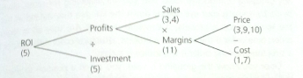
Whenever businesspeople talk about things like costs, sales, prices, investment, and ROI, they are implying their knowledge of the relationships between these things as displayed on a standard ROI tree. If you impose the relevant points on such a tree, it is relatively easy to see what his message is:
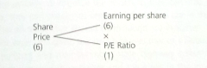
The points about Earnings per Share and Price/Earnings Ratio suggest another tree:
We are then left with two points: No. 8, we must borrow, and No. 2, there is a risk that we won’t be able to sell because of a ban on nonreturnable bottles. The borrowing point can be fitted into the tree if I add another layer below profits to make room for taxes and interest. I’ve left this out to make the technique easier to comprehend.
If we try to put it all together, he appears to be saying -
We should think carefully before going into the plastic bottle business:
If there is a nonreturnable ban, we may be precluded from doing so. Even if there is no ban, it would dilute our profitability.
Short term, lower EPS.
Long term, lower ROI.

Now that you see what the message is, what is left out of the author’s thinking, apparently, was an assessment of the effect of plastic containers on the sales of the product.
The point I wish to reiterate is that you cannot tell that nonsense is being written unless you first impose a structure on it. It is the imposition of the structure that permits you to see flaws and omissions.

Checking order is a key
To summarize, I have tried to demonstrate with all these examples that checking order is a key means of checking the validity of a grouping. With any grouping of inductive ideas that you are reviewing for sense, always begin by running your eye quickly down the list. Are they indeed all from the same source: a process, a structure, a class? Are they all in logical order: time order if the source is a process, structural order if the source is a structure, ranking order if the source is a class.

Chapter 8 Question the problem-solving process
One of the reasons people group together ideas in writing that do not have a clear logical relationship is that they have unconsciously drawn them haphazardly from a preconceived structure. By forcing themselves to visualize the structure, they can match their points to it. Thus, they can check not only that the points are in the right order, but also that all those that should be included are included.
Once you saw the match between its activities and the ideas in the grouping, the proper order became obvious. A consulting firm will give a document known as a Letter of Proposal, such letters spell out for a prospective client what his problem is and how the consulting firm proposes to go about solving it. If the proposal is accepted, the consulting firm will then carry out the analyses required to solve the problem and write a report embodying its findings, conclusions, and recommendations. Coming up with those findings, conclusions, and recommendations requires the creation and use of a number of analytical structures. These structures, in turn, must be referred to in checking the order and completeness of the ideas generated by them.
Writing documents that detail the results of problem solving, whether in consulting or in business, may find it useful to review the general problem-solving process and some of the analytical structures associated with it, as a basis for looking critically at what is said.

The problem-solving process
The problem is either that you do not like the result, or that you cannot explain the result. Changing the result in the first instance calls for the application of routine problem-solving skills. Finding the explanation in the second demands the somewhat more creative hypothesizing of scientists and inventors. Here we are talking about routine problem solving. The simplest process consists of answering a series of questions in logical sequence:

- What is the problem?
- Where does it lie?
- Why does it exist?
- What could we do about it?
- What should we do about it?

The answer to each question must be structured visually before you can be said fully to understand what you have found. The problem situation you face can be very murky, and information can come at you in a random way, in a variety of misleading or overwhelming forms. And you always have the personalities of the people with whom you are working to consider. When you sit down to put your thoughts in order prior to writing, you try to force an analytical structure on your findings and conclusions.

What is the problem?
The problem is that you do not like the result. To what precisely do you object? How will you know when the problem is solved? In effect, what question do you want your analysis to answer? What you want to do here is to try to create a clear image of exactly what you mean.

Where does the problem lie?
In creating a useful structure of the situation, you are trying to show how the elements in the situation relate functionally and interact as a system to accomplish a specific purpose. Sometimes these relationships are not at all obvious, so that to diagram them you must first do a good deal of digging. Keep digging until (1) you are sure you have identified all the parts in the system, (2) you can arrange them in sequential order, and (3) you can clearly show inputs and outputs.

Why does the problem exist?
The overall structure of the situation will indicate a number of directions in which your analysis can proceed. In more complex situations, you will have to probe more deeply into both the things and processes that make up the structure. You will be trying to make clear the components of each, their importance to each other, and how the change over time. Clearly, in these more complex situations you will also have to be selective. Not all possibilities are likely to prove equally important in solving the problem. Consequently, you will have to make a judgement early on about which areas deserve the greatest concentration of effort. Such judgments can only be based on experience in the industry or in solving similar problems, and are thus generally made by senior members of the consulting staff.

What could we do about it?
Once the situation has been visualized and analyzed, so that you know why the problem exist. You have a good idea of what needs to be changed. However, there may appear to be alternative ways to change, each of which derives logically from the structure of the activity under study. They must now be tested to determine which way most effectively creates the desired result.

What should we do about it?
In making the decision to choose one alternative over the next, you must be able to visualize the new situation with the change implemented. Creating this picture should suggest to you the additional changes that must be made to accommodate it, and once again highlight the points that need analysis and verification before you make a final recommendation.
With the numerical consequences clear, you next want to explore the risks involved in achieving them. Risks in this context would generally be of three kinds: you will have made a mistake in your assumptions, you might not achieve your objective, or you may inspire retaliation of some kind. Should it look as though the choice is very risky for any one of these reasons, you would want to stop considering it as an alternative.
Before you can legitimately advise someone on how to change an undesirable result, you must have defined clearly five things: 1) the gap between where he is and where he wants to be, 2) the structure of the situation that gave rise to the gap, 3) the structure of its underlying processes, 4) the alternative ways the structure could be changed, and 5) the changes required to accommodate the alternative you choose.
You can see that completion of Step 1 tells you not only how to direct your analysis of the problem, but also how to write your introduction. It identifies the question your report must be structured to answer. Step 2 and Step 3 identify the major analyses that must be completed before you can formulate recommendations to answer the question. In looking critically at the draft of a report, you will want to make sure first that the introduction reflects a clear definition of the problem, and then that the findings and conclusions derive from appropriate analytical structures.

Defining the problem
- Where you are now
- Where you want to be
- The difference between the two
The problem must be explained in detail before giving a solution. Whenever you outline the problems in a system, you are by implication stating the actions that must be taken to correct the problems. Thus, a rule of thumb you should always organize this kind of paper around the changes needed, supporting each suggested change with a discussion of the system and its weaknesses. Visualizing the before, the after, and the differences between the two makes it easy to be specific about what the changes should be.
If these are the major points to be communicated, they can form the Key Line of the pyramid. It is now a simple matter to work backward to determine what information has be communicated in the introduction to induce the reader to ask that question. In this case, he need only be reminded that he knows about the problem, that he asked to have a suggested solution put in writing, and that now the document will tell him the solution.
In most case, with a little effort, you will find it relatively easy to visualize both the situation within which the problem occurs and the way it will look when the problem is solved. You need these to guide the writing of your introduction and to give direction to your analysis.

Structuring the analysis of the problem
A logical structure must have existed to produce the results that you observe. An excellent method for doing so is to create what are known as logic trees, of which there are several varieties. Let me describe five, you can use the logic-tree concept to find gaps and illogicalities in what you have written.

Five Typical logic trees
The great value of logic trees lies in the fact that they can often reveal where the problem is, why it exists, and what to do about it all in one picture. The trees differ slightly depending on the kind of structure being shown.

Financial structure
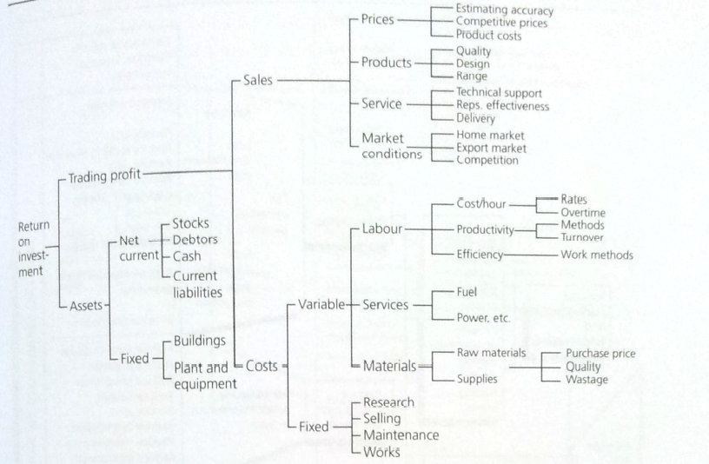
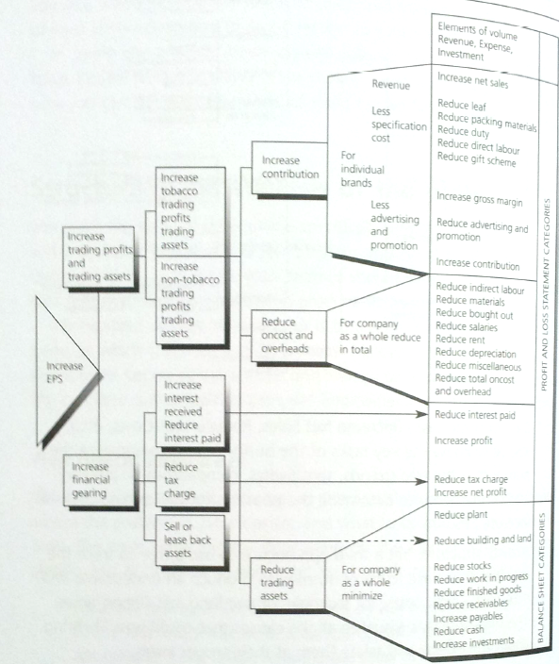
Such as an ROI tree that lays out part of the financial structure of a company, and then permits you to ask question like ‘What might cause sales to be off?' and ‘What might cause that cause?’ The tick is to create a mutually exclusive and collectively exhaustive group of causes at each branch.

Task structure
A deeper, more explicit approach is to make the tree show the important tasks of the business that it must organize itself to perform. To do so, you begin with EPS and divide the tree in terms of the company’s financial structure, stating each element as a discrete managerial task. Then you impose the Profit and Loss Account and the Balance Sheet on this structure, again stating each item as a task.

Activity structure
Use a tree to trace the activities that have to be performed to produce an undesirable end objective – high costs, for example. The trick here is to visualize all the causes that could possibly bring about the effect, and related them at their proper levels. You begin your tree with the effect you are trying to understand, at next level you hypothesize the mutually exclusive and collective exhaustive reasons that this could occur. You then take each possible reason and break it down further. You ask in each possibility, why would this happen? The result is a list of the areas where facts must be gathered and analyzed.

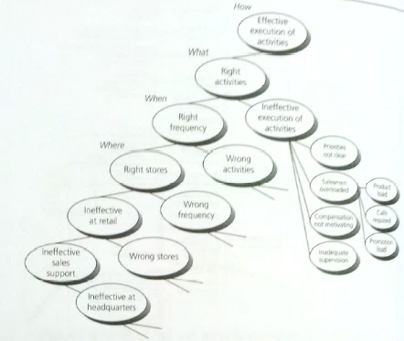
Choice structure
Like Activity structure but simply display bifurcate choices until you reach a level where you have more precise knowledge of the likely causes. The secret to this choice diagram is to visualize the sequential process involved, and reflect it in your bifurcations. The result again is a list of the analyses that must be performed, and that will tell you how to solve the problem.

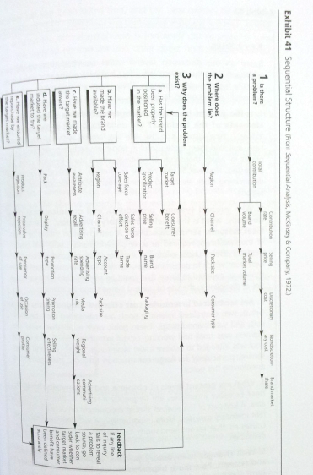
Sequential structure
A more sophisticated version of the choice structure, The value of this structure lies both in its completeness and in the order in which analyses of each element are meant to be performed.

Use of the logic-tree concept
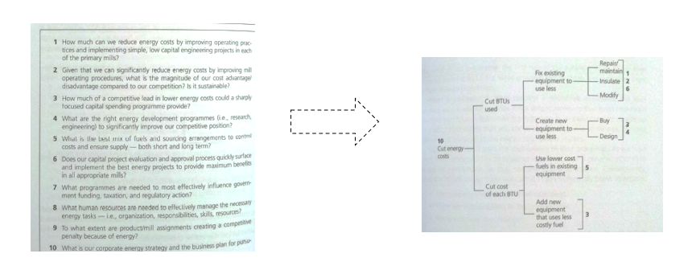
Once you understand the technique for displaying the logical relationships between groups of activities, to show their cause-effect nature, you can use the concept to question the logic of what you’ve written.

Remember, all groupings of ideas must have had their origin in an analytical activity of the mind. In situations where you are trying to solve a problem, the likelihood is that your groupings derived from one for another of the structures you created to guide your analysis. Matching your ideas to these structures can help you to verify their logical validity.

Chapter 9 Questioning the summary statement
The first rule of the pyramid: ideas at any level must be summaries of the ideas grouped below them, because they were in fact derived from them. Most writers don’t state the implications of their groupings. As we have seen, their tendency is to tie together ideas that have a general rather than a specific relationship, so that nothing is directly implied. Consequently, they are forced to cap them with what I call intellectually blank assertions:
- The company should have three objectives.
- There are two problems in the organization.
- We recommend five changes.
These statements in fact don’t summarize the essence of the ideas grouped below them. They simply state the kind of idea that will be discussed. As such, they cannot serve as nuggets on which to focus future thinking. The major purpose of summarizing a grouping – to glean an insight about which you can then think further. You will take that summary point and either find others like it (induction) or comment further on it (deduction). But you must have a true summary before the process can begin.
A second reason you want clear summary statements is that it makes life easier for the reader. A document studded with intellectually blank assertions is boring beyond belief to read because it does so little to anchor the reader’s perceptions. In addition, there is a real danger that he could misunderstand you.
How to make a proper summary? First, as the previous has shown, you must check the origin of the grouping to make sure it is MECE (i.e., that its order reflects a process, a structure, or a classification). Then you look at the kind of statement you are making. Regardless of the origin of the idea, its expression will be either as an action statement, telling the reader to do something, or as a situation statement, telling the reader about something.
- Summarize the action ideas by stating the effect of carrying out the actions.
- Summarize the situation ideas by stating what is implied by their similarity to each other.
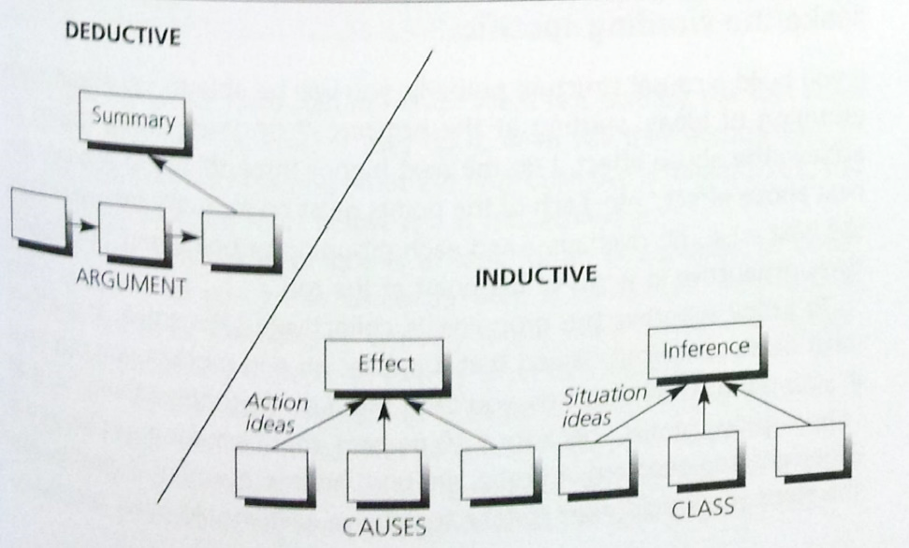
Thus, summarizing inductive groupings means either determining the effect of actions or drawing an inference from conclusions.

Stating the effect of actions
The great majority of ideas in business writing are statements of actions – i.e., statement described by such plural nouns as steps, recommendations, objectives, or changes. You use them when writing manuals, stating actions plans, describing systems, or spelling out how to go about solving a problem. Since actions are always taken to achieve some purpose, you place these ideas in a causal structure that groups them under the effect they are meant to achieve. As you can see, if you have a large number of steps to carry out in getting to the end result, the hierarchical structure makes it easy for the reader to grasp how they all relate and the order in which they must be carried out.
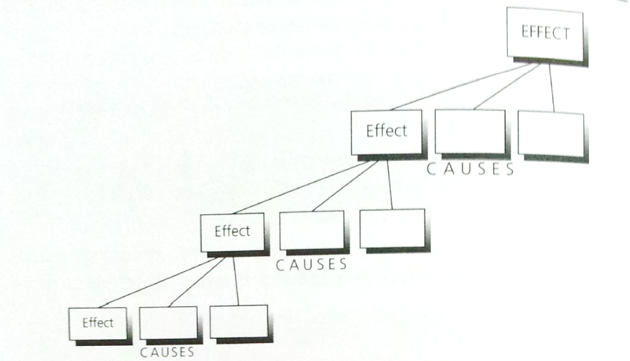
Sorting actions by their effect is an alien kind of activity for most people, while separating various causes from various effects at a number of levels abstraction leaves them in chaos, logically speaking. There are many reasons for this, chief among them the fact that writers habitually state actions so vaguely that it is difficult for them to determine their precise effects. In addition, very often a writer doesn’t understand the difference between a cause and an effect, and in any case his tendency is to want to group by similarity, since that’s his most common thinking activity.

Make the wording specific
If you build a causal structure properly, you will be able to say about each grouping of ideas, stating at the bottom, ‘I do these three things to achieve the above effect, I do the next higher three things to achieve the next above’, etc. Each of the points must be mutually exclusive from the next – i.e., no overlaps – and each grouping of points must be collectively exhaustive in terms of the point at the top.
To judge whether the grouping is collectively exhaustive, the effect must be so specifically stated that it implies an end product you can hold in your hand. In other words, you can’t say, ‘I do these three things so that I can improve profits’, because a 10 percent improvement in profits and a 2 percent improvement in profits are both an improvement, but the steps you would need to take to achieve each would differ greatly. To be both clear to the reader and useful to yourself in checking your thinking, the point should say something like, ‘I do these things so that I can improve profits by 10 percent by January 15’. This kind of statement permits you to judge whether the steps you have grouped together underneath would in fact bring about this end result.
You will not always have a clear numerical goal as your end product. But there will always be some tangible way to judge that the step has been completed. A useful technique is to visualize a real person actually taking the action, so that you can judge how he will know when he is finished. By that criterion, this sentence is almost pure gibberish –
A world consciousness must be developed through which every individual realizes his role as member of the world community.
What does that mean you should do? How will you know when you have done it? Can you visualize someone ‘realizing this role’? If you cannot, you do not know what the author means. Here is another example where you do not know –
To reduce the chance that conflict will turn to confrontation rather than healthy debate and consideration of issues on their merits, the Task Force must be able to:
Handle a variety of personal attitudes.
Build favorable rapport with company personnel.
Develop good interviewing skills.
Plan and conduct interviews effectively.
Learn to gain agreement on suggestions while maintaining an objective posture.
What can the writer have had in mind? What is it the Task Force must do? And to what end? If do it, what will they accomplish? As you can see, without knowing what the final objectives is meant to be, you cannot judge that the steps below will in fact achieve it.
Remember that the technique is to look for an end product or cutoff point that will let you know when the step is completed. To illustrate, opposite are some examples of typically vague statements made in business writing, each translated into exactly what was meant. You can see that each translation is easier to comprehend because it brings an image into the mind. This of course makes the document much more interesting to read. More important, without this end-product orientation you cannot tell with confidence what the next step should be.
What was said | What was meant
Strength regional effectiveness | Assign planning responsibility
Reduce accounts receivable | Establish a system for following up overdue accounts
Review management processes | Determine whether management processes need to be revised
Improve financial reporting | Install a system that gives early notice of change
Tackle strategic issues | Define a clear long-term strategy
Redeploy manpower resources | Place people in positions of comparable responsibility
With the statements in the left, nothing could identify the obvious need for another step. You will have noted that an idea can serve as both a cause and an effect in a structure. Consequently, all steps should be written so that they imply an end product. When your language does not obey this rule, you confuse your assessment of the proper cause-and-effect relationships. To illustrate an extreme case, take the following set of steps of what a project staff should do -
Identify high-potential profit-improvement projects
- Review background data
- Define your key task
- Collect data for the key task
- Review events and trends affecting the key task
- Identify possible projects
- Measure profit impact of improved performance
- Assess possible level of improvement and profit impact
- Prepare a draft Profit-Improvement Project Plan
The first step, ‘Review background data’, states an essentially meaningless guideline for action. How does one know when he’s finished reviewing the data? Is the end product of the review a judgment? A plan of action? Does ‘review’ mean read? Assess? And if you look at the sub steps for guidance on the meaning of ‘review’, you find that this cannot in fact be what the person is meant to do.
The purpose of the sub steps(define the key task, collect the data, etc.) must be to bring about the major step stated above them. Accordingly, you must be able to ask, ‘I do these three things so that what will happen?’, here the ‘what ’ cannot logically be ‘so that you can review background data’. A similar complaint can be made about the three sub steps under Step 2, ‘Identify possible projects’.
A good part of the writer’s problem here lies in the imprecision of the language he has used to state the steps. The author can give a better listing of the steps using below words.
ORIGINAL STATEMENT | CLARIFICATION
1 REVIEW BACKGROUND DATA
- Define your key task | - Select an operating activity when cost and investment
- Collect data for the key are high | - Look at evidence of poor task performance
- Review events and trends | - List likely future changes in operating conditions that would make correcting performance of no value
2 IDENTIFY POSSIBLE PROJECTS
- Measure profit impact of improved performance | - Measure profit impact of correcting poor performance
- Assess possible level of improvement and profit | - Assess the level of profit improvement actually likely to be obtained
- Prepare draft PIP plan | - Estimate the analyses required and people needed to follow up the project
 | - Work out a timetable for their activities
This analysis demonstrates some common errors to look for you group steps to form a system. Ask yourself the following questions about any grouping:
- Does the same step appear in more than one place? In the original listing here, for example, the overall step and Step 2 (Identify high-potential profit improvement projects and Identify possible projects) are essentially the same point.
- Can I visualize someone taking the action? If you can’t, it means you have not stated the end product clearly, which makes it difficult to determine precisely what the reader needs to be told next. Try to think of the end product as being in the reader’s hand at the end of the step, and then make your next statement convey an action that builds logically from this situation. Visualizing someone using the end product can help you avoid this kind of vagueness.
- Will the sub steps bring about the step above them?
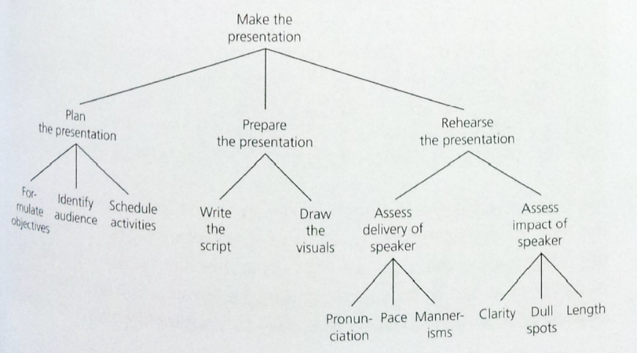
- Have I kept the subject the same? As I mentioned earlier, an action statement always implies that someone specific is taking the action. Whoever the specific someone is must stay as the same person throughout the system, or you will find yourself saying something other than what you precisely mean.
In the above tree, for example, you can put ‘you should’ in front of all steps except nodes under ‘Rehearse the presentation’, Does the author mean ‘you should’ address the delivery of the speaker and the impact of the speaker, when in fact you are the speaker? Of course not. More likely, he means something like:
- Run though the presentation in the presence of a colleague.
- Ask him to assess your delivery and its impact.
- Incorporate his suggestions in a second run-through.
To summarize, statements about actions are sometimes so numerous that they need to be grouped. To be valid, the groupings must be arranged hierarchically as causes leading to the same effect. The wording of each cause or effect should be such as to imply a clear end product resulting from the accomplishment of the step. When it does not do so, you do not in fact say exactly what you mean. At best, that makes your writing dull; at worst, it makes it useless.

Distinguish the levels of action
Even if you get the language right, telling cause from effect can be tricky. In a causal hierarchy, an idea is an effect if you expect the reader to take the action before he takes the next action on the same line. It is a cause if you expect him to take it so that an end product can be created. Sometimes, you will in fact be dealing with actions that you have worded as if they were conclusions. In most cases, a conclusion about the cause of a problem implies the action required to correct it. Since positive recommendations for action are more interesting to read than negative conclusions about problems, it make sense to turn them into an action structure. For example, suppose you had drawn the following ‘major conclusions’:
- Although the company’s sales force has significant strengths to build upon, substantial efforts will be required near term to ensure future competitive viability.
- Increases in sales force manpower are required to increase sales call capacity and meet intensified competition.
- Specialized attention is necessary to improve your competitive position with chain headquarters buying offices.
- Field representatives may not be allocating their time optimally to achieve maximum sales potential.
- Increased merchandising requirements and the need for additional selling capacity dictate the necessity for specialized merchandising resources.
- Significant manpower increases will require the formation of additional districts and additional management levels.
- A formal field sales strategy is needed to provide direction to field personnel.
- Standardized quantitative measures are needed to guide and evaluate sales resources.
The first step would be to restate those that imply actions as actions. That would mean restating all but the first one, as follow:
- Add salesman.
- Assign specialized salesmen to HQ accounts.
- Tighten account scheduling process.
- Hire part-time merchandisers.
- Add more districts and management levels.
- Create sales strategy.
- Standardize quantitative measures of work
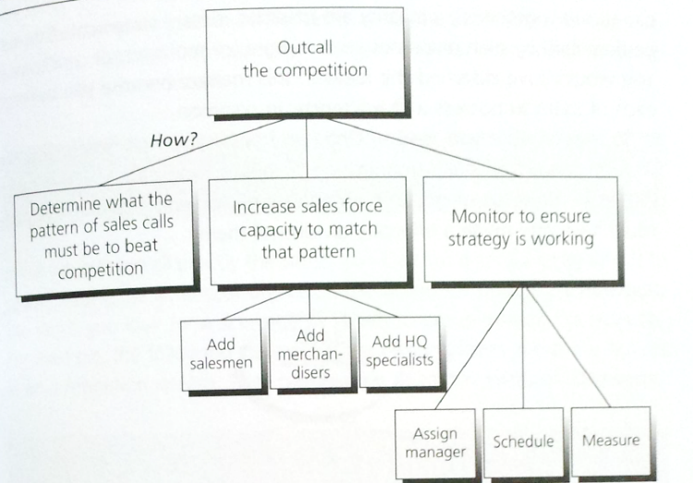
Clearly these are not in end-product terms, but that is not necessary at this stage when you are sorting out your thinking. The technique is to decide roughly what goes with what in terms of cause and effect, and then restate the points to be totally clear. Thus, you would note that 2,3, and 5 are all adding people, so that their effect would be to increase the size of the sales force. Number 4, 6, and 8 have to do with managing the sales force. Number 7 stands alone, so that roughly this being said:
- Create a sales strategy
- Increase the size of the sales force.
- Manage the sales force.
Why are we doing these things? Apparently to keep our competitive lead. And if we do them all, what in effect will happen? Essentially, it seems we will outcall our competition.
In closing this section, let me just point out that you cannot group action ideas by similarity rather than by effect. If you try to do so, you will find that you no longer have mutually exclusive groupings, nor will you be able to judge whether you have been collectively exhaustive in listing your actions.
For example, if one author said -
The Chairman’s job can be divided into two corresponding tasks:
Dealing with the subject.
Dealing with the people.
Because sometimes the Chairman must do both kinds of things at once, the points as stated could not have been arrived at analytically.

Drawing an inference from conclusions
What you can group together by similarity are situation ideas – statements that can be described by such plural nouns as reasons, or problems, or conclusions. You would have classified the ideas in this manner because you believed each of them to possess a characteristic in common. You want to be as specific as possible, since the clearer your definition, the easier it is to make a general statement that applies to them all.
It is not always easy to state specifically what a particular set of ideas has in common, since it requires some creative insight. However, there is a technique you can use, which you may already have noted my using in the discussions of earlier examples. That is first to find the structural similarities in the sentences in which the points appear, and then to visualize the relationships implied between the parts that are similar.

Find the structural similarity
Ideas are always written in sentences that have a subject/predicate structure. Thus, the common property linking the ideas will usually show up because the sentences all:
- Discuss the same kind of subject.
- Express the same kind of action or object.
If the subjects are exactly the same, you look for a similarity by which to group among the actions or objects. If the actions or objects are all exactly the same, you look for a similarity by which to group among the subjects.
Sometimes you will not find any relationship at all between the points. That is always an indication that there is something wrong with your grouping and that further thinking is required before you can say precisely what you mean. Take this listing as an example –
- The planning cycle and its attendant control mechanism should be on an annual basis.
- The plans should be built up via an integrated system.
- The plans should be compiled in the context of a strong directional lead from the top of the division.
- The planning system will distinguish between the current practice and the planned change.
These points say that the things to note about the planning system are that it is annual, integrated, begins at top, and distinguishes between present and future. So what? That’s like your telling me that your wife is five feet eight inches tall, has honey blond air, like green dresses, and drive a Buick. I can’t put those four points together into an overall statement that will tell anything interesting about your wife.
On the other hand, if you tell me your wife is five feet eight inches tall, has honey blond hair, wizard legs, and her measurements are 36-24-36, then I can say, ‘Wow, she must be a knockout lady’. In the first case, you have made four related comments from which I can draw a larger idea, and then continue to think about that idea.
This impetus to think further, the major reason for drawing inferences in the first place. A grouping of ideas does not push your thinking upward, and therefore cannot guide it forward on this particular subject.

Visualize the relationships
How you actually draw an inference from a proper grouping is a bit difficult to explain with precision. You have assembled in your grouping a collectively exhaustive class of observations about a subject, and you now want to make a statement about the class as a whole.
Essentially the statement should give an insight into the implications of their being similar in the way they are. Achieving that insight requires a so-called inductive leap. The springboard for that leap is likely to be a visualization of the source of the relationships reflected in the grouping.
Example – 1
- Productivity figures for accounting, estimating, and surveying should be updated.
- Regular personnel turnover figures are now necessary for all types of employees.
- Competition information from tenders should be gathered so that the strength of competition in different markets can be monitored.
- The present information about market rates for salaries is not adequate.
- Division and project capital lockup figures are needed.
It is said the information:
- Should be updated.
- Is now necessary.
- Should be gathered.
- Is not adequate.
- Is needed.
They clearly fall into two distinct groups: those complaining that the information does not exist (2, 3, and 5), and those complaining that the information exists but not adequate (1 and 4). So we see that the list implies that there are two problems with the information system.
Now, why these two problems and no others? What is the same about them that made the author instantly recognize them as problems that should be grouped together? Possibly because these defects indicate a uselessness for planning purposes. In that case, the point the author would state at the top would be: ‘The planning system as presently set up produces information that is useless for planning purposes’. Why? Because either the information needed doesn’t exist, or it exists but it’s not adequate.
Example 2 –
- Market is large and growing at an attractive rate.
- Aftermarket is profitable.
- Key market characteristics indicate high barriers to entry.
- Overall trends are favorable, but uncertainties obscure some market segments’ outlooks.
- Overall, the market appears attractive, but is highly fragmented.
As you can see, since the subject is the same in each case (aftermarket), the points relate to each other by predicate. But they go together only if the predicates can be found to fall into the same category or categories. You can instantly see that there are both positive and negative points being made.
- Positive points: large, growing, attractive, profitable, favorable, trends, attractive
- Negative points: barriers to entry, uncertainties, fragmented.
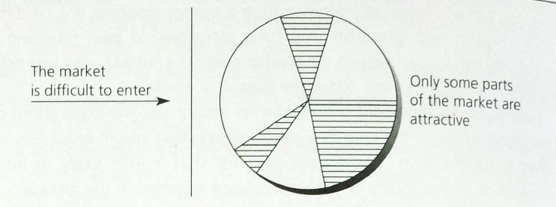
Clearly if the market is large, growing, and profitable, it is attractive. Let us visualize this attractive market with a circle.
The negative points don’t group easily. Fragmented means that the circle must have some segments in it, but uncertainties obscure some segments’ outlooks. This means some of the segments must look different from the others. Finally, he says there are barriers to getting in, now what conclusions can we come to from the visualization?
- Only some parts of the market are attractive
- These are going to be difficult to get into.
That sounds like the beginning of a deductive argument. The author has left off the ‘therefore’ point, which means he never bothered to complete his thinking. No wonder he found it difficult to write a clear summary statement of the points.
Sometimes you will be presented with groupings that look like situation ideas, but are really action ideas in disguise. Begin by treating them as if they were classed together because of their similarity, and then switch the form if you can visualize the effect that together they would achieve.
Example 3 –
There are four variables to be managed in the resource allocation process:
- Sequence and timing of activities
- Definition of specific people’s tasks
- Definition of information needs (content and form)
- Decision-making process
Why these four variables and no others? What is the same about them that made him group them together? If you try to state them more specifically, so as to find an order, you will see that the author is probably saying this –
The four variables are:
- Spelling out the sequence and timing of project planning activities
- Specifying where decisions are needed
- Identify who will participate in making them
- Defining the information they need to do so
These have now become a clear series of actions. Why would I want to take these four actions? What would be the effect? I suppose it would be to fix it so that everybody who should participate does so, and does so properly. The summarizing point then might be:
The major management task in the resource allocation process is to ensure early and substantial participation of the proper people.
Similarly, suppose you went on to say -
Definition of content and form of information is often critical:
- Determines what information is generated – and used
- Broadens perspective of participants
- Focuses attention on key issues
- Facilitates collaboration across functional and divisional lines
Again you question. Why these four reasons and no others? What is the same about them that makes the author bring them together? You would then note that the last three have to do with the behavior of the participates, while the first one is in a way saying the same thing as the point on top. Then why the three and on others? Perhaps he means to be saying this –
Defining what information is needed and how it should be presented can be critical to gaining agreement and understanding:
- Focuses the participants’ attention on key issues
- Broadens their perspective
- Facilities their collaboration across functional and divisional lines
Before you start objecting to the difficulty of forcing your thinking upward every time, let me admit that you’re not going to be enforcing this discipline absolutely rigidly throughout all your writing – not because it’s not a useful thing to do, but because you don’t always need that degree of precision.
How do you judge whether you’ve seen sufficiently precise? In general, if you can think of as many points outside the group as in the group to which the overall statement could apply, you will know that is not sufficiently precise to serve as a valid inference about the grouping.
Example 4 –
Composing room costs may represent a profit-improvement opportunity:
- Low productivity
- High overtime
- Uncompetitive prices for simple jobs
If I see a company that has low productivity, high overtime, and uncompetitive prices, I can infer that here is a profit-improvement opportunity. However, I can substitute three other points (e.g., high scrap yield, poor timekeeping, undisciplined systems) and still infer that there is a profit-improvement opportunity. The point at the top is too board to make a statement about these three points and no others.

Another imprecise example, this time properly inductive in form.
Example 5 –
Japanese firms are now escalating their drive for the Chinese market.
- The Toyota Motor Company sent official representatives to the Canton trade fair.
- Japan Air Lines is negotiating to fly into China.
What about Mitsubishi, or Hitachi, of half of a dozen others that come to mind? Two examples do not justify a generation about all Japanese firms. The question raised in the reader’s mind by the general statement will be sufficiently answered by the two points below.

The message to take away from this discussion is that you cannot simply group together a set of ideas and assume your reader will understand their significance. Every grouping implies an overall point that reflects the nature of the relationship between the ideas in the grouping. You should first define that relationship for yourself, and then state for the reader.
Always ask yourself of any group, ‘Why have I brought together these particular ideas and no others?’ The answer will be either that they all fall into the same narrowly defined category, and are the only ideas that do fall into that category, in which case your summary point will be a statement about their sameness. Or that they are all the actions that must be taken together to achieve a desired effect, so that the summary point states what the effect is.
You should force yourself to justify each grouping of ideas in this way, so that you are sure that your thinking is dead clear and that your writing reflects it.

Chapter 10 Putting it into readable words
Writing anything clearly consists of two steps: first decide the point you want to make, then put it into words. Once you have worked out your pyramid structure and rechecked the thinking in your groupings, you know exactly the points you want to make. All that remains is for you to put them into words. In theory this should be a relatively easy task. One ought to be able to expect the normal business writer to translate his pyramided points into a series of concise, graceful sentences and paragraphs that clearly convey a lively message and capture the reader’s interest. Alas, it does not always happen. The average sentence, far from being concise and graceful, is long-winded and heavy with jargon. This makes the paragraphs seem impenetrable and the subject endlessly boring.
Anyone who can explain his ideas orally and be completely comprehensible may believe that, in writing, the more dehydrated the style and the more technical the jargon, the more respect it will command. This is nonsense. Good ideas ought not to be dressed up in bad prose. Works on technical subjects can at the same time be works of literary art. Of course technical communications addressed to specialists must employ technical language. But overloading it with jargon and employing a tortuous and cramped style is largely a matter of fashion, not of necessity.
Your objectives should be to dress your ideas in a prose that will not only communicate them clearly, but also give people pleasure in the process of absorbing them. This, of course, is advice that every book on writing gives, and if it were easy to do, everyone would be doing it. It is not easy to do, but there is a technique that can help. What it primarily requires is that you consciously visualize the images you used in thinking up your ideas originally.
As must be obvious by now, you do all your conceptual thinking in images rather than in words. It is more efficient to do so. An image can take a great mass of facts and synthesize them into a single abstract configuration. Given the inability to think about more than seven or eight items at one time, it is a great convenience to be able to compress the world in this way. Without it you would always be limited to taking decisions on the basis of a few low-level facts. To compose clear sentences, then, you must begin by ‘seeing’ what you are talking about. Once you have the image, you simply copy it into words. The reader, in turn, will re-create this image from your words, thereby not only grasping your thinking but also enjoying the exercise.

Create the image
What you were building was a memory image, not a photographic image, it grows piecemeal as you go along. The reader is constructing the passage as he read. The result of this constructive activity is a memory image that summarizes the information presented. You construct the image as part of the process of understanding, and the image then helps you to remember what you have read.
If you put the book down and try to remember what you read, you will probably find that you can’t repeat it verbatim. But if you recall the image you can read off from it what you see, and it will be roughly equivalent to the original.
That images help to increase recall has been proven in memory studies, although these studies also show that people forget some details and embellish others, depending on their emotional predilections. Nevertheless, the memory image does provide a record of the passage and of the information extracted from it – a record that the reader constructs as he reads, phrase by phrase.
This is the kind of thing that must happen every time you read anything if you are to comprehend and remember it. Some passages are more difficult to visualize than others, and if the ideas being presented are particularly abstract, it may be that you will represent them with skeletal structures rather than with images. But unless the passage can be visualized in some form, unless the reader can actually ‘see’ what is being said, he cannot be considered to have understood it.
One does not want a complete, detailed photographic reproduction, but only a sense of the structure of the relationships being discussed. These will generally consist of one or more geometric forms (e.g., circle, straight line, oval, rectangle), arranged in a schematized of sketchy fashion, plus something like an arrow to indicate direction and interaction.

Copy the image in words
Using these basics to create images can make a very great difference to rewriting bad prose. Because the words as laid out fail to call to mind an image as you read, your mind gropes in vain for something solid to hang onto. The trick is to find the nouns and look for the relationships between them, seeing them as a visual image.

Summary
A useful way to help yourself write lucid prose is to force yourself to visualize the relationships inherent in your ideas. Once you have a clear mental image, you can straightaway translate it into a clear English sentence, which your reader can just as straightforwardly interpret and absorb. And he has the additional advantage of being able to store this knowledge in his memory in image form.
Storing knowledge in image form is essential given the word-by-word process of reading and our limited ability to hold many words in our minds. By rescuing the image from the words, the reader is able not only to transfer the knowledge in large chunks, which are more efficient for his mind to process, but also to transfer it as a vivid impression, which makes it easier to recall.
In writing you are as a commander filing out his battalion through a narrow gap that allows only one man at a time to pass; and your reader, as he receives the troops, has to re-form and reconstruct them. No matter how large or how involved the subject, it can be communicated only in that way. What an obligation we owe the reader of order and arrangement – and why, apart from felicities, and curiosities of diction, the old rhetorician laid such stress upon order and arrangement as duties we owe to those who honor us with their attention.
Go thou and do likewise.

Appendix Problem solving in structureless situations
The solution of the problem will always lie in tinkering with the structure as indeed it will if the problem is that we do not like the result the structure is yielding. However, there is another king of problem situation where the problem is that you can’t explain it, one of three reasons –
- Because the structure does not yet exist – as when you are trying to invent something new (e.g., the telephone, underwater, tunnelling)
- Because the structure is invisible – as in the brain or DNA, so that you have only the results of the structure to analyze
- Because the structure fails to explain the result – as when tools rust mysteriously no matter what you do to guard against it
It is possible that you may confront one of these structureless situations in the course of an ordinary problem-solving assignment. Although such situations require a higher level of visual thinking than we have been discussing, you will be pleased to know that the reasoning process employed is very similar.

Analytical abduction
In any reasoning process you always deal with three distinct entities:
- A Rule (a belief about the way the world is structured)
- A Case (an observed fact that exists in the world)
- A Result (an expected occurrence, given the application of the Rule in this Case)
The away in which you can consider yourself to be reasoning at any one time is determined by where you start in the process and what additional fact you know. To illustrate the differences:
Deduction
Rule | If you put the price too high, sales will go down. | If A then B
Case | We have put the price too high. | A
Result | Therefore, sales will go down. | Necessarily B

Induction
Case | We have put the price up. | A
Result | Sales have gone down. | B
Rule | The reason sales have gone down is probably that the price was too high. | If A then probably

Abduction
Result | Sales have gone down. | B
Rule | One reason sales go down is that the price is too high. | If A then B possibly.
Case | Let me check whether in fact the price is too high. | A

We have been saying throughout that analytical problem solving consists of noticing an undesired Result, looking for its cause in our knowledge of the structure of the situation (Rule) and testing whether we have found it (Case). You can see that this exactly matches the Abductive reasoning process shown above.
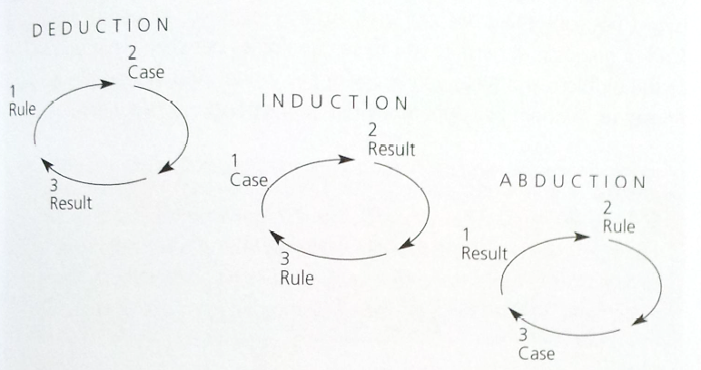
In any complex problem-solving situation you are likely to be using all three forms of reasoning in rotation. The form you are using, and the results you can expect from it, depend on where you start in the process.

Scientific Abduction
The major difference between the analytical problem solving and creative or scientific problem solving is that we know the structure that creates our result and the scientist doesn’t. That is, we have two of the essential elements and can reason our way to the third. He must invent the second before he can reason to the third. In reasoning to the third, the scientist follows the classical scientific method:
  - Hypothesize a structure that could explain the result.
  - Devise an experiment that will confirm or exclude the hypothesis.
  - Carry out the experiment to get a clear yes-or-no answer.
  - Recycle the procedure, making sub hypotheses or sequential hypotheses to define the possibilities that remain, and so on.
The hallmarks of the scientific method are generating hypotheses and devising experiments. Both activities demand high levels of visual thinking. Once the hypothesis is formulated, the next step is to use it to suggest experiments that will confirm or deny it. The trick in structuring an experiment is to make sure that it will yield a clear-cut, yes-or-no answer. It is not enough ‘to see what happens’ if you change one or another of the conditions in the situation. The result of the experiment must allow you to state unequivocally whether you will keep or discard the hypothesis. It is in the sciences that have most rigorously applied this particular requirement that the greatest advances in our knowledge have occurred over the last 50 years.

Techniques of Problem Solving
Basic Process | Analytical Problem Solving | Scientific Problem Solving
- What is the problem | Visualize the difference between the result you get now and the result you want | Define the discrepancy between the result you get and the result you should expect to get given the prevailing theory
- Where does it lie? | Visualize the structure elements in the present situation that could be causing the result | State the traditional assumptions of the theory that might give rise to the discrepancy
- Why does it exist? | Analyze each element to determine whether it is doing so, and why | Hypothesize alternative structures that would eliminate the discrepancy and explain the result
- What could we do about it? | Formulate the logical alternative changes that could produce the desired result | Devise experiments that will exclude one or more of the hypotheses
- What should we doing about it? | Create a new structure incorporating those changes that will produce the result most satisfactorily | Reformulate the theory on the basis of the experimental results
Each step demands a clear end product that you can literally see; each image indicates the direction in which the subsequent analyses should lead. When the problem has been solved, the images serve as anchors to guide the course of your discussion and the choice of your words.

