How to Change a Paradigm
https://www.proctorgallagherinstitute.com/6104/how-to-change-a-paradigm

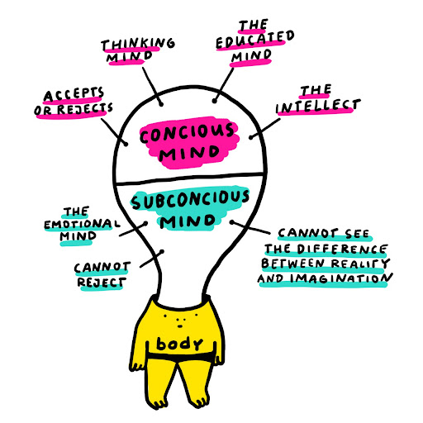
The information you just learned will change your life in phenomenal ways—if you take action on it.

But before you get started, you have to be clear on a few things.

First, remember that a paradigm is a multitude of habits that are lodged in your subconscious mind.

Second, you must change the paradigm in the same way it was created—through repetition of information.

And, third, you must understand that to change a paradigm you have to consciously and deliberately replace a “bad” habit with a good habit. Otherwise, you’re going to form another bad habit because nature abhors a vacuum.

Start the process by consciously choosing new beliefs that are aligned with the habits you want, and then plant them in the place of the old beliefs in your subconscious mind.

One way to do this is through affirmations. Find positive statements that mirror the beliefs or behaviors you want to incorporate and read the statements over and over again. If you want more money, you can use the affirmation I shared with you in the video…

I am so happy and grateful now that money comes to me in increasing quantities, through multiple sources on a continuous basis.

Another powerful tool you can use is visioneering, which is where you create a new image of yourself being, doing, or having the things you want. Sandy is a master at this! Practicing this a few times a day will go a long way in helping you change bad habits and attract the things you want into your life.

You can also do the following exercise:
- Think about a result you’re getting that you don’t want and ask yourself what behaviors or habits are causing that result.
- Write the behavior out in crystal clear detail.
- Ask yourself what habit or behavior is the polar opposite of the behavior you just identified.
- Write out the new behavior on another sheet of paper.
- Burn the paper that contains the bad habit (as a symbolic gesture).
- Write the positive habit out four or five times a day. Read it frequently. You will eventually lodge that idea in your subconscious mind.
Once it begins to take root, it takes the power away from the bad habit and the bad habit actually dies from lack of nourishment. Then, the deposited one takes over.

Now it will take a fair amount of energy and understanding to do these things, but I promise you it will be very much worth the effort because it will allow you to write your own ticket in life.

When I changed my paradigm back in 1961, my life literally changed like night and day.

So get started. And let me know how you’re doing.

I’ll see you at the top!

To your success,

Bob Proctor
Chairman & Co-Founder
Proctor Gallagher Institute

What Is Ego Depletion?
By Kendra Cherry Medically reviewed by Daniel B. Block, MD on May 28, 2021

Caiaimage/Rafal Rodzoch/Getty Images
Think about how you feel after a long, busy day. After running errands, working on projects, and rushing to appointments, do you still feel like you have the energy to work on your goals? Once the day was done, you probably want to collapse in front of the TV and avoid doing anything at all.

The reason you might find yourself so exhausted and burned out after a hard day can be influenced by what psychologists refer to as the ego-depletion effect.

What Is Ego Depletion?
People are often faced with urges, desires, and natural tendencies that demand satisfaction. Giving in to such feelings is not always realistic, socially acceptable, or even healthy. In order to deal with such challenges, people must exert self-control in order to regulate their actions. Very often, we need to delay gratification of these urges until a more appropriate time and place.1﻿

Such self-management takes a great deal of mental effort, both cognitive and emotional. Some of these efforts require less willpower, while others demand much more. Even relatively minor acts of self-control can take a toll.

Ego depletion happens when people use up their available willpower on one task.2﻿ As a result, they are unable to exert the same level of self-control on subsequent, often unrelated tasks.

Willpower is a limited resource.The idea behind this theory is that willpower is like a muscle in that it can be both strengthened and fatigued. For example, if you exhaust yourself doing sprints, you will be less able to perform other physical tasks.

Research has suggested that willpower and self-control are much the same. If you use your available energy and reach a state of ego depletion, you will have less self-control when faced with ensuing tasks.

Self-control is important. Having good self-control is beneficial in a number of ways. People who possess high levels of self-control may have better relationships and higher achievement levels.3﻿ Those who lack self-control, on the other hand, can experience social conflict and poor academic performance.

Willpower and the Psychology of Self-Control

Research
The concept of ego depletion has taken some hard knocks in recent years.4﻿ Some reviews of the research have suggested that the effect may be less powerful than previously believed. And an updated meta-analysis concluded that the ego depletion does not exist at all.5﻿

Other researchers have proposed that ego depletion is not merely a result of draining limited self-control resources. Instead, they suggest that shifts in motivation, attention, and emotion play a critical role.6﻿

In a study exploring this theory, participants first completed a task designed to deplete willpower.7﻿ Some of the participants were then told that the purpose of the study was to provide evidence supporting a new therapy that would help people with Alzheimer's disease.

Participants who had been given this incentive were motivated to perform well for the benefit of Alzheimer's patients, leading them to outperform those in the control group. Motivation, the research suggests, plays an important part in ego depletion.

Causes
A variety of factors can contribute to ego depletion and make it harder to control yourself and regain your willpower, including:

- Emotional distress: If you're feeling emotional distress, your willpower will be depleted more quickly.
- Unfamiliarity: It takes more energy to try something new.
- Illusory fatigue: If you think a situation will be mentally taxing, you'll become mentally fatigued faster.
- Low blood sugar: Having low blood sugar can make it more difficult to resist temptation.8﻿
- Choice: If you're forced to do something, you'll have less self-control than if you were allowed to make your own decision.
- Cognitive dissonance: Doing or saying something that contradicts your beliefs can diminish your self-control.
- Heart rate: Researchers have found that more your heart rate varies, the less self-control you have.9﻿
- Hormones: Women have been found to experience decreased self-control during premenstrual syndrome, as the ovaries work harder during this phase of menstruation.10﻿
- Age: Older people may be more resistant to ego depletion than their younger counterparts.

Examples
There are many examples of how ego depletion can impact your behaviors in both large and small ways. What might happen if you find yourself low on self-control due to ego depletion?

Giving Up on Your Weight-Loss Goals
Dieting is one of the most obvious examples of how ego depletion can sabotage your willpower.11﻿ You might spend all day diligently sticking to your diet. You eat a healthy breakfast and lunch, and even resist the sweet snacks that a co-worker brings into the office during your mid-afternoon break.

That night, as you arrive home from work, you find that your resolve has grown weak and you no longer have the self-control to stick to your diet.12﻿

Because you have expended so much mental energy throughout the day resisting the urge to indulge, you have reached a state of ego depletion by dinner time. Instead of eating the healthy meal you planned, you order take-out from your favorite fast-food restaurant and spend the evening watching TV and snacking on chips.

Less Likely to Help Others
Ego depletion has also been shown to have an influence on what is known as prosocial behavior, or social interactions designed to help others.13﻿ When people reflect back on their own behaviors, they sometimes experience feelings of guilt. It is these guilty feelings that sometimes lead people to behave in prosocial ways.

Studies have shown that people who are ego depleted experience fewer feelings of guilt.13﻿ In studies where people were induced into an ego depleted state, these participants were less likely to experience feelings of guilt and therefore less likely to engage in prosocial actions.

Effects
So what impact does ego depletion actually have on your day-to-day life? There are a number of ways that this phenomenon can influence your behaviors and decisions:

Dieting
Researchers have found that chronic dieters are more prone to ego depletion than non-dieters14﻿ . Because dieters apply so much willpower to controlling their food intake, they become more prone to losing self-control in the face of temptation.

For example, in one study participants (some who were dieting and some not) had to either sit next to a bowl of tempting snacks or far away from the desirable treats.15﻿ When the participants were later given the chance to eat ice cream, those who were dieting and had to sit right next to the bowl of treats ate more ice cream than the other participants. Because they had to use so much willpower to resist eating the snacks, these participants depleted their self-control resources.

Decision-Making
Studies have also found that when shoppers experience ego depletion, they are more likely to make poor or impulsive purchasing decisions.16﻿ The sheer number of choices that consumers face can lead to such depletion. Consumers are forced to weigh an enormous number of choices. This complexity leads shoppers to become overwhelmed and frustrated.

Once a state of low self-control has been reached, buyers will purchase items based on simple criteria such as the cheapest item or the product linked to higher status. You have probably experienced this yourself if you have ever found yourself grabbing something off the shelf just because it was the lowest priced or a name brand that you recognized.

Performance
Mental toughness and determination are critical for athletic performance, but researchers have found that these tend to decline following difficult mental tasks.17﻿ This suggests that the depletion of willpower due to mental demands can actually impair performance on physical tasks. For student-athletes, this might mean that taking a challenging exam right before a game might actually hurt their performance.

Substance Use
Some research suggests that depleting self-regulation can also leave people susceptible to impulsive behaviors, including excessive or chronic alcohol consumption.18﻿ This can be challenging for individuals prone to substance use or abuse. Exhausting self-control on unrelated tasks might then make it more difficult to say no when temptation strikes. Ego depletion has also been linked to quitting smoking, contributing to smoking cessation failure.19﻿

Prevention
Ego depletion can have a serious impact on your motivation, success, and performance. So what can you do to minimize the effects of this drain on willpower and self-control?

Improve Your Mood
Researchers have found that being in a positive mood can have a beneficial impact on self-control. In some studies, ego depleted participants who had their moods boosted by watching comedy films actually performed just as well on self-control tasks as non-ego depleted participants.20﻿

Change Your Outlook
In one study, researchers found that participants who viewed themselves as tired were also more likely to experience ego depletion.21﻿ Those who were able to step back and focus more on the big picture rather than just their own self-perceptions were able to reverse this effect. By focusing on your overall goals rather than just your feelings in the moment, you can minimize the impact of ego depletion.

Think About What Matters to You
Research has also shown that acts of self-affirmation can counteract the effects of ego depletion.22﻿ Self-affirmation refers to any behavior or thought that boosts integrity of the self. One simple but highly effective form of self-affirmation involves expressing your core values—the beliefs that you hold dear. During times when you are feeling exhausted and stressed, take a moment to remind yourself of the things that matter to you the most.

How to Use Positive Affirmations for Stress Relief

Prioritize Sleep
Sleep resets your self-control and provides you with the mental energy needed to have willpower throughout the day. Similarly, lack of sleep makes self-control more difficult. Think about how much harder it is to resist junk food when you're sleep deprived than when you have a good night's rest.

Practice Stress Management
Managing your stress can not only help strengthen your self-control, but it can help you better manage those areas in your life that are depleting your energy and willpower. Taking time to practice relaxation strategies throughout the day, like deep breathing or mindfulness meditation, can also help recharge your mental energy.

A Word From Verywell
Understanding ego depletion has important implications. Because self-control plays such a critical role in so many areas of life, finding ways to improve it can enhance overall well-being.

People are often encouraged to marshal their willpower to overcome any challenge—but sometimes the act of doing so can leave us lacking control later on when we really need it.

If you feel like your resources are depleted, look for ways to boost your willpower during critical moments. Uplifting activities like enjoying a funny movie or focusing on the things that are important to you can give you a boost when you are feeling depleted.

The Psychology of Motivation and Reaching Your Goals

Decision Fatigue and How to Avoid Bad Choices
Why do we make unhealthy and unproductive choices — even when we know we should do better?

If you ask most people, they will say that poor choices are a result of a “lack of willpower.”

But research from Columbia University is beginning to reveal that willpower doesn't quite work that way.

In fact, you may be surprised just how much small daily decisions impact the willpower you have for important choices. And most importantly, it turns out there are simple choices you can make that will help you master your willpower and make better decisions on a more consistent basis.

Why Some Criminals Don't Get a Fair Hearing
In a research study published by the National Academy of Sciences, psychologists examined the factors that impact whether or not a judge approves a criminal for parole.

The researchers examined 1,112 judicial rulings over a 10-month period. All of the rulings were made by a parole board judge, who was determining whether or not to allow the criminal to be released from prison on parole. (In some cases, the criminal was asking not for a release, but rather for a change in parole terms.)

Now, you might assume that the judges were influenced by factors like the type of crime committed or the particular laws that were broken.

But the researchers found exactly the opposite. The choices made by judges are impacted by all types of things that shouldn't have an effect in the courtroom. Most notably, the time of day.

What the researchers found was that at the beginning of the day, a judge was likely to give a favorable ruling about 65 percent of the time. However, as the morning wore on and the judge became drained from making more and more decisions, the likelihood of a criminal getting a favorable ruling steadily dropped to zero.

After taking a lunch break, however, the judge would return to the courtroom refreshed and the likelihood of a favorable ruling would immediately jump back up to 65 percent. And then, as the hours moved on, the percentage of favorable rulings would fall back down to zero by the end of the day.

This trend held true for more than 1,100 cases. It didn’t matter what the crime was — murder, rape, theft, embezzlement — a criminal was much more likely to get a favorable response if their parole hearing was scheduled in the morning (or immediately after a food break) than if it was scheduled near the end of a long session.

The figure below depicts the odds that a judge will make a favorable ruling based on the time of the day. The dotted lines signify food breaks taken throughout the day.

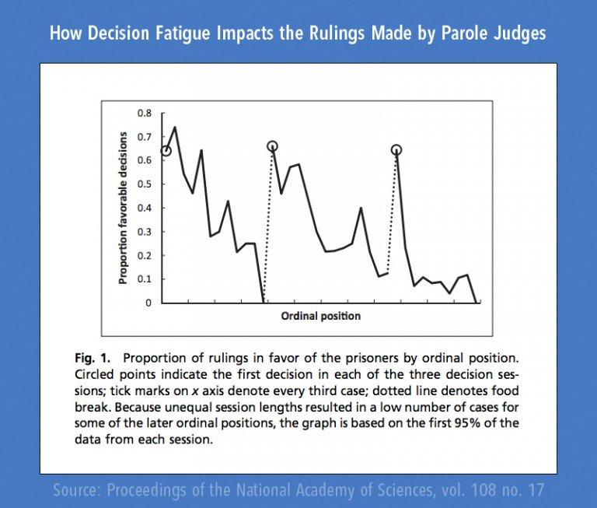

This graph displays the odds that a criminal will receive a favorable response from the judge based on the time of day when the hearing occurs. Notice that as time goes on, the odds of receiving a favorable response decrease. (Graphic by James Clear.)

What's Going on Here?
As it turns out, your willpower is like a muscle. And similar to the muscles in your body, willpower can get fatigued when you use it over and over again. Every time you make a decision, it’s like doing another rep in the gym. And similar to how your muscles get tired at the end of a workout, the strength of your willpower fades as you make more decisions.

Researchers often refer to this phenomenon as decision fatigue. When the judge on a parole board experiences decision fatigue, they deny more parole requests.

This makes sense. When your willpower is fading and your brain is tired of making decisions, it’s easier just to say no and keep everyone locked up than it is to debate whether or not someone is trustworthy enough to leave prison. At the beginning of the day, a judge will give each case a fair shot. But as their energy starts to fade? Deny, deny, deny.

Here’s why this is important for you…

Do You Suffer From Decision Fatigue?
Decision fatigue happens every day in your life as well. If you have a particularly decision-heavy day at work, then you come home feeling drained. You might want to go to the gym and workout, but your brain would rather default to the easy decision: sit on the couch. That’s decision fatigue.

The same thing is true if you find it hard to muster up the willpower to work on your side business at night or to cook a healthy meal for dinner.

And while decision fatigue is something that we all deal with, there are a few ways that you can organize your life and design your day to master your willpower.

5 Ways to Overcome Decision Fatigue and Boost Willpower
1. Plan daily decisions the night before.

There will always be decisions that pop up each day that you can't plan for. That's fine. It's just part of life.

But for most of us, the decisions that drain us are the ones that we make over and over and over again. Wasting precious willpower these decisions — which could be automated or planned in advance — is one reason why many people feel so drained at the end of the day.

For example, decisions like…

What am I going to wear to work? What should I eat for breakfast? Should I go to the dry cleaner before or after work? And so on.

All of those examples above, can be decided in 3 minutes or less the night before, which means you won't be wasting your willpower on those choices the next day. Taking time to plan out, simplify, and design the repeated daily decisions will give you more mental space to make the important choices each day.

2. Do the most important thing first.

If there was the most important court case in the world, when would you want the judge to hear it?

Based on the research above, first thing in the morning. You’d want their best attention, energy, and focus to go toward the decisions that were most important.

The same thing goes for your work and life. What’s the most important thing for you right now?

Is it getting in shape? Is it building your business? Is it writing that book you have inside of you? Is it learning to eliminate stress and relax?

Whatever it is for you, put your best energy toward it. If you have to wake up 30 minutes earlier, then do that. Start your day by working on the most important thing in your life.

I've written previously about the importance of morning routines and time management, this research on willpower is just another reason to work on the most important things first.

3. Stop making decisions. Start making commitments.

I think advice like, “you just need to decide to do it” gets dished around too much.

Yes, of course you need to decide to do the things that are important to you, but more than that you need to schedule them into your life.

We all have things that we say are important to us.

“I really want to scale my business.”

“I really want to lose 40 pounds.”

“I really want to get started on XYZ.”

Unfortunately, most of us simply hope that we'll have the willpower and motivation to make the right decisions each day.

Rather than hoping that I'll make the right choice each day, I've found much more success by scheduling the things that are important to me.

For example, my schedule for writing is Monday and Thursday. My schedule for weightlifting is Monday, Wednesday, Friday. On any given Monday, I don’t have to decide whether I'm going to write. It’s already on the schedule. And I’m not hoping that I’ll have enough willpower to make it to the gym. It’s just where I go on Mondays at 6pm.

If you sit back and hope that you’ll be able to make the right decisions each day, then you will certainly fall victim to decision fatigue and a lack of willpower.

4. If you have to make good decisions later in the day, then eat something first.

It’s no coincidence that the judges became better decision makers after eating. Now, if you cram french fries into your veins every day, then I doubt that you'll enjoy the same results. But taking a break to feed your brain is a wonderful way to boost willpower.

This is especially important because although it’s great to do the most important thing first, it’s not always possible to organize your day like that.

When you want to get better decisions from your mind, put better food into your body.

5. Simplify.

Whether you are trying to reach the highest level of performance or just want to start eating a healthy diet, the biggest frustration for most people is the feeling that you need to use willpower on an hourly basis.

Find ways to simplify your life. If something isn't important to you, eliminate it. Making decisions about unimportant things, even if you have the time to do so, isn't a benign task. It's pulling precious energy and willpower from the things that matter.

Willpower is one area of life where you can most certainly improve your output by reducing the number of inputs.

The Bottom Line
Willpower isn't something you have or something you lack. It rises and falls. And while it's impossible to maximize your willpower for every moment of every day, it is possible to make a few changes to your day and your routine so that you can get the most of your decisions and make consistent progress on the things that are important to you.

Footnotes

