目录
Improve Communication Skills at Work 1
Scope and Objective 1
What are some of top communication needs at work? 1
Why is effective communication important? 1
What's stopping you from communicating effectively? 2
What are the keys to effective communication? 2
Do you know your audience? 2
Manage your stakeholders 3
Tips to effective stakeholder engagement 3
Tips to become an engaged listener 3
Tips to present concisely and precisely 3
Tips to effective written communication 4
Tips to be candid and open 4
Tips to assert confidence 4
Tips to control your emotions 5
Other tips to improve communication generally 5

Improve Communication Skills at Work
Eugene Wang, https://youtu.be/HAQ4p74KbdY

Scope and Objective
- Focus on daily communication at work
- Clarify the importance of effective communication at work
- Identify common barriers to effective communication
- Define keys to effective communication
- Provide some best practice and tips on how to improve communication skills

What are some of top communication needs at work?
- Coordinate project execution with other team members on the same project
- Request resources allocation from other stakeholders based on identified dependencies
- Formally communicate project status
- Ask for help!
- Escalation through the reporting chain to resolve a conflict
- Continuous improvement of your domain knowledge and development of your career

Why is effective communication important?
- Defined "Effective communication is more than just exchanging information. It's about understanding the emotions and intentions behind the information."
- Make informed decisions.
- Improve productivity.
- Build relationships.
- Manage Stakeholder engagement.
- Provides visibility for you and your project.
- Resolve conflicts or settle disagreements.
- Communication style and effectiveness is usually an indicator of org culture.

What's stopping you from communicating effectively?
- Eager to get our point across without hearing what others have to say.
- Lack of confidence in your written and verbal communication skills.
- Lack of focus on the subject matter.
- Lack of ability to recognize and adopt specific aspects of communication style/standard at your work.
- Afraid of confrontation.
- Lack objectivity when receiving feedback(e.g. you take negative feedback personally)

What are the keys to effective communication?
- Know your audience
- Become an engaged listener.
- Present information that is concise and precise.
- Be candid and open.
- Assert confidence and be recepitve to feedback.
- Control your emotions.

Do you know your audience?
Groups or individuals which you need to frequently communicate with include:
- Stakeholders directly involved on your project, e.g. products managers, designers, software developers, Legal, etc.
- Peers in the same org as you, e.g. team members of other projects.
- Superiors (immediate manager or 1-level up), e.g. your immediate manager, or managers from the same org.
- Executives, e.g. SVP or VP who is your project sponsor.
- Your formal and informal mentors.

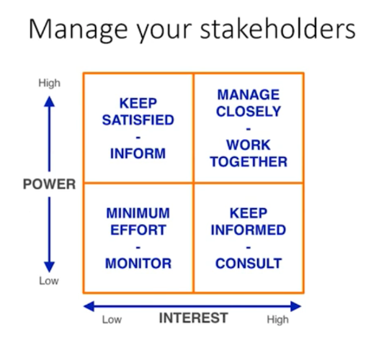
Manage your stakeholders

Tips to effective stakeholder engagement
- You are transparent about all relevant information (e.g. related to your project)
- You communicate with stakeholders in ways(e.g. emails, documents, etc.) that work best for them.
- Dot NOT judge what your stakeholders value, instead try to understand why.
- Provide feedback to stakeholders how their concerns or asks are addressed and resolved.
- Keep a record of all stakeholder communication that occur over time.

Tips to become an engaged listener
- stay focused while engaged, e.g. stay off your phones and laptops.
- Avoid interrupting the speaker or redirect the conversation.
- Make eye contact.
- Mind your body language.
- Show interests, e.g. ask questions.
- Don't judge.
- Provide feedback.

Tips to present concisely and precisely
- Think if you had just 3 minutes, what would you say?
- 5 Ws - why, what, who, when and where?
- Answer a question directly, e.g. starts with "yes" or "no" before elaborating.
- Focus on things that are impactful, e.g. why is this information important?
- Always include data, e.g. what's the expected business or customer impact?
- Pratice - if you bump into your VP in the pantry, and he says, "How is it going with ...?", what would you say in 3 sentences?

Tips to effective written communication
Component | Question | Example
Context | Why is this information relevant to me? | As part of the broader effort to drive new user activation ...
Goals & Objectives | What are we trying to achieve? | Unlock a new customer cohort or expand share of wallet of an existing cohort.
Use case | What problem are we trying to solve? | Allow business users to purchase multiple copies of a digital eBook.
Qualification and Quantification | Why is this problem important? | +xx% in total units of eBooks purchased(annualized)
Proposed Solution | What are we going to address this problem? | Lanuch a new eBook purchase experience that allows bulk purchase eBooks.
Success Measurements | How do we know that our solution worked or not? | Net increase to total eBook sales without net negative impact to eBook purchase conversation.
Priorities and Timelines | When are we going to do that? | MVP includes ...

Tips to be candid and open
- Stick to facts, e.g. let metrics speack for themselves.
- Assume best intentions, e.g. everyone wants the best experience for customers.
- Get the point, e.g. articluate a specific concern.
- Be objective, e.g. just because someone disagrees with you does NOT make them wrong!
- Be empathetic and don't kill the messenger, e.g. it takes a lot courage for someone to bear unpleasant news.
- Collect feedback, e.g. ask for other opinions.

Tips to assert confidence
- Not afraid to disagree, e.g. learn to say no.
- Know your stuff, e.g. build up your subject matter expertise.
- Speak with clarity, e.g. focus on the main point.
- Defend your point of view without being defensive, e.g. back up with data and anecdotal evidence.
- Own up to mistakes, e.g. no afraid to say you were wrong or you don't know.
- Seek feedback, e.g. welcome challenges.
- Show respect, e.g. treat less senior team members with equal respect.

Tips to control your emotions
- Have clear goals in mind, e.g. what are you trying to get out of a conversation or meeting?
- Pause to collect your thoughts, e.g. don't feel that you need to rush into responding.
- Willing to compromise, e.g. finding a middle might be the path forward.
- Look for humor in a dire situation, e.g. don't take yourself or topic too seriously.
- Agree to disagree, e.g. table a conversation that's not going anywhere to determine next course of action.

Other tips to improve communication generally
- Learn to speak in public, e.g. there are ample resources available to help such as Toastmasters.
- Take professional or business writing classes to improve written communication.
- Prepare before an important meeting, e.g. write down key points on a piece of paper.
- Practice with your peers and friends, e.g. dry-runs before a formal presentation always helps.
- Write better emails, e.g. your manager and co-workers will recognize and appreciate it.
- Find mentors, e.g. use your formal and informal mentors for coaching and guidance.

